DIVINE SERVICE FOR
THE BAPTISM OF OUR LORD

LEBANON LUTHERAN CHURCH
Lebanon Church, VA

January 10, 2021

The congregation assembles. Silent prayer is offered upon entering the pews.

WELCOME

The bells.

Holy Spirit, Light Divine Hymn of Invocation
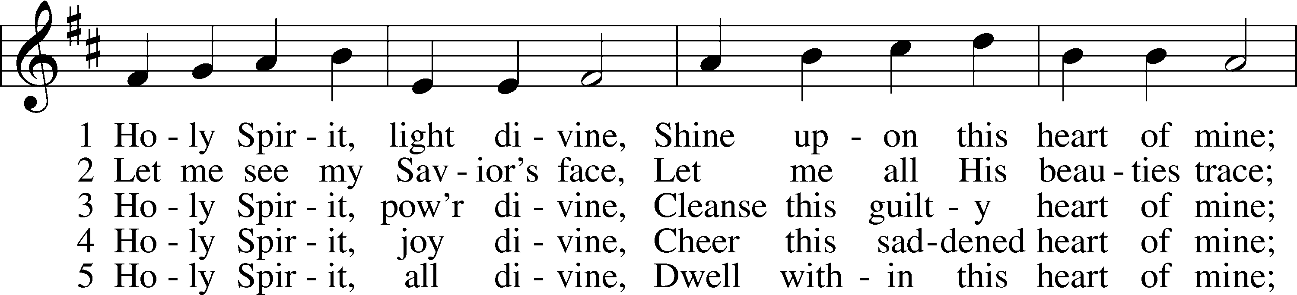
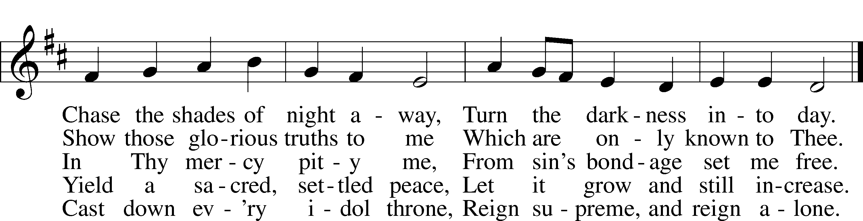
Tune and text: Public domain

PREPARATORY OFFICE

The sign of the cross may be made by all in remembrance of their Baptism.

Invocation
P In the name of the Father and of the T Son and of the Holy Spirit.
C Amen.

Collect for Purity
P Almighty God, unto whom all hearts are open, all desires known, and from whom no secrets are hidden, cleanse the thoughts of our hearts by the inspiration of Your Holy Spirit that we may perfectly love You and worthily magnify Your holy name; through Jesus Christ, our Lord.
C Amen.

Exhortation
P If we say we have no sin, we deceive ourselves, and the truth is not in us.
C But if we confess our sins, God, who is faithful and just, will forgive our sins and cleanse us from all unrighteousness.

Silence for reflection on God’s Word and for self-examination.

Confession of Sins
P Let us then confess our sins to God our Father.
C Most merciful God, we confess that we have sinned against You in thought, word, and deed, by what we have done and by what we have left undone. We have not loved You with our whole heart; we have not loved our neighbors as ourselves. We justly deserve Your present and eternal punishment. For the sake of Your Son, Jesus Christ, have mercy on us. Forgive us, renew us, and lead us, so that we may delight in Your will and walk in Your ways to the glory of Your holy name. Amen.

Declaration of Grace
P In the mercy of almighty God, Jesus Christ was given to die for us, and for His sake God forgives us all our sins. To those who believe in Jesus Christ He gives the power to become the children of God and bestows on them the Holy Spirit. May the Lord, who has begun this good work in us, bring it to completion in the day of our Lord Jesus Christ.
C Amen.
Stand

SERVICE OF THE WORD

Apostolic Greeting
P The grace of our Lord T Jesus Christ, the love of God, and the communion of the Holy Spirit be with you all.
C And also with you.

Kyrie
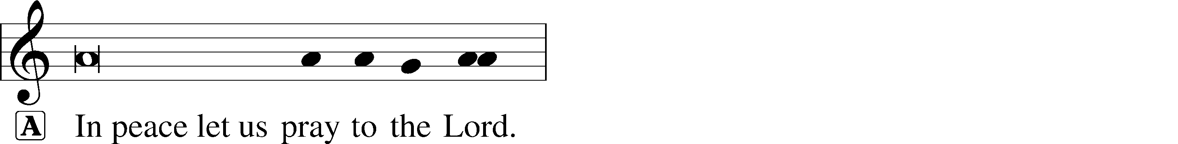
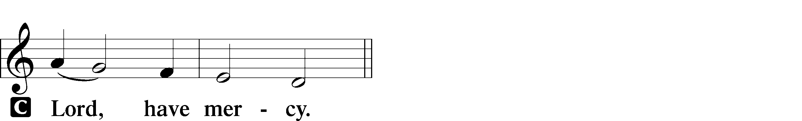

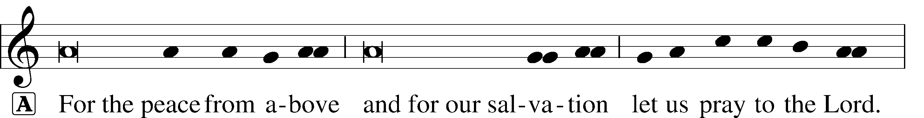
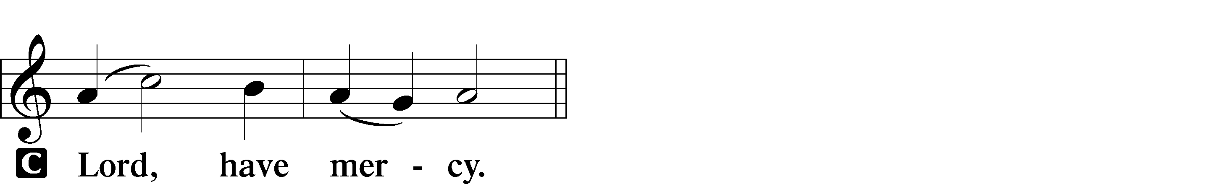

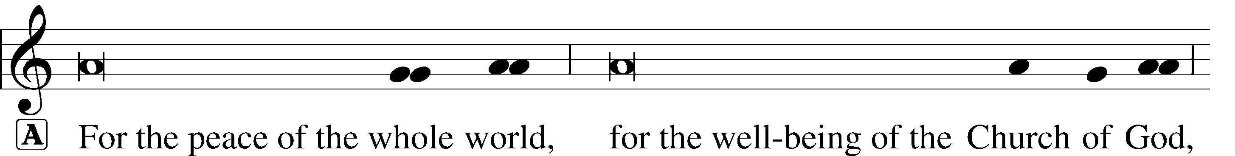
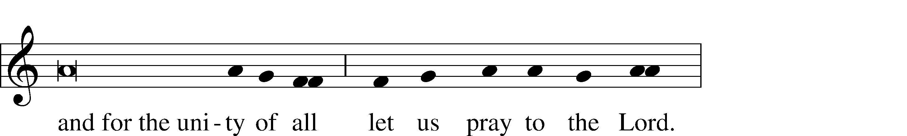
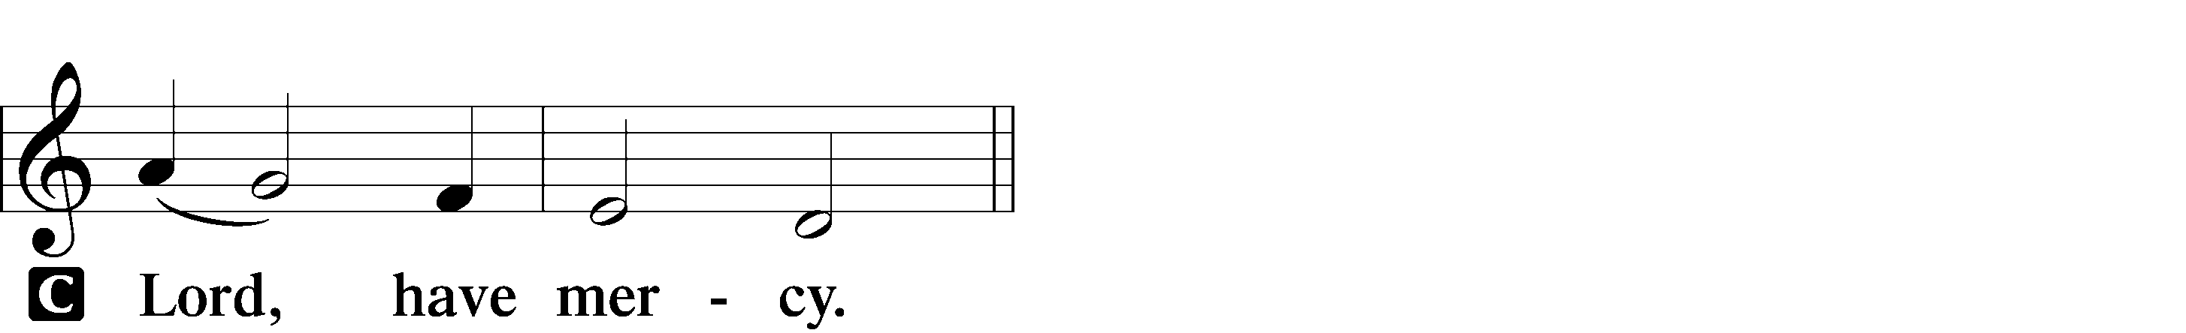

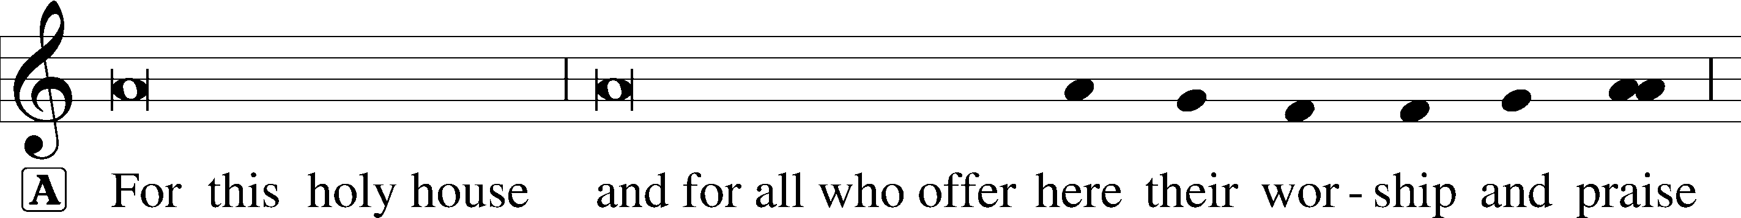
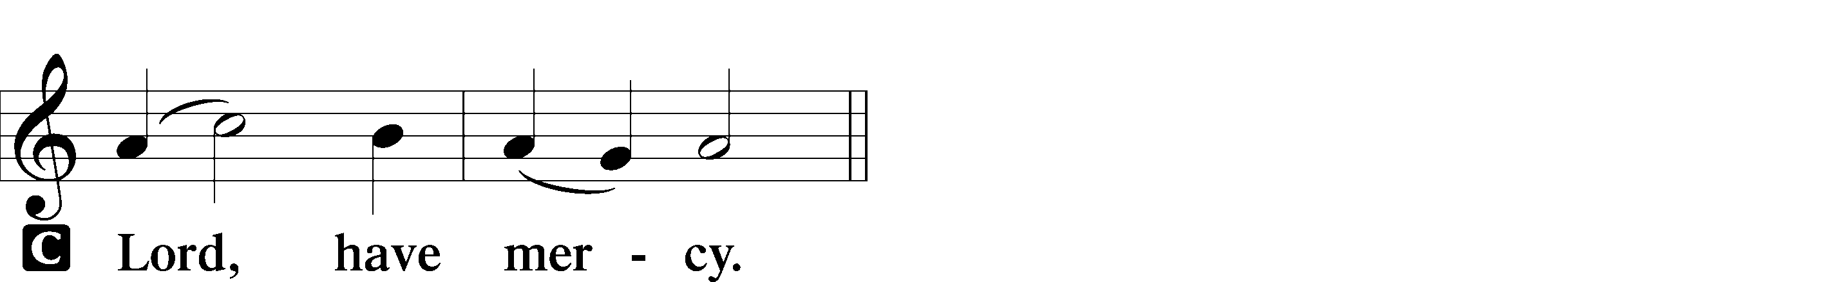

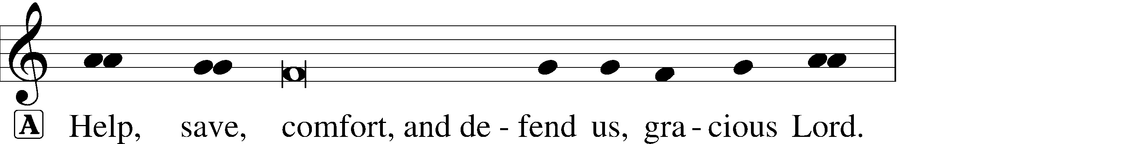
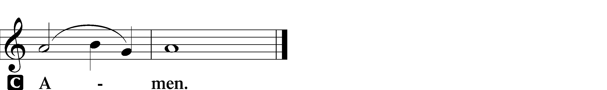

Gloria in Excelsis
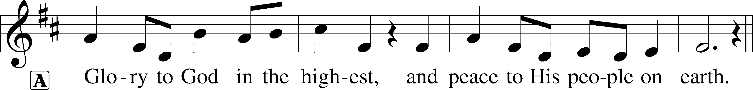
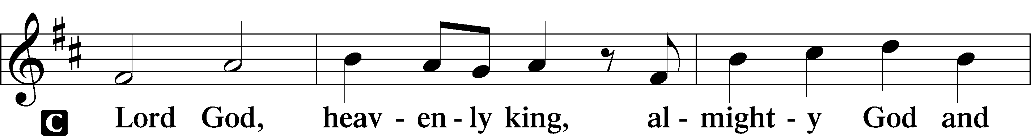

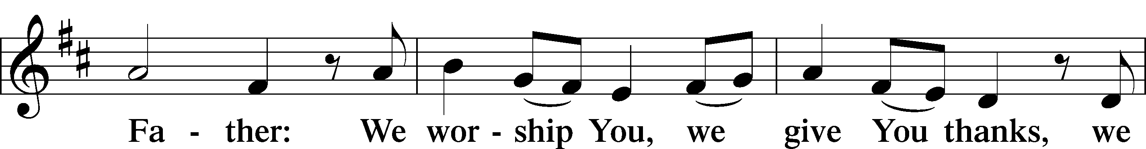
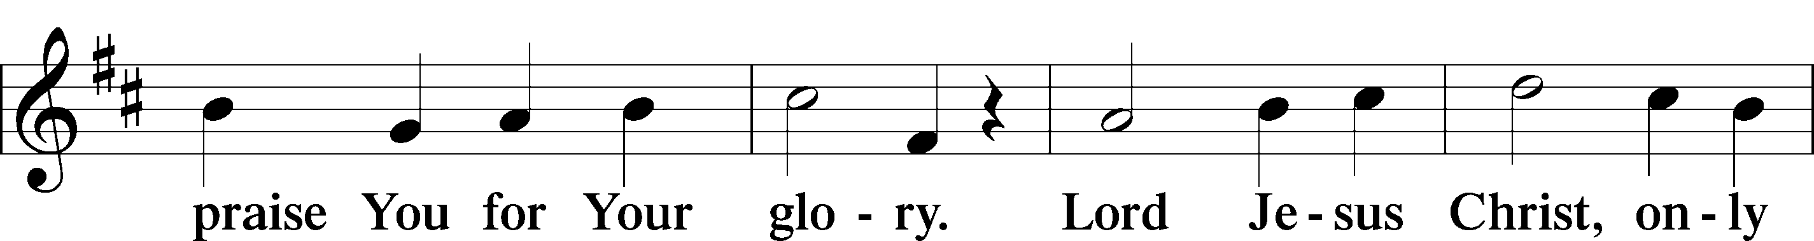
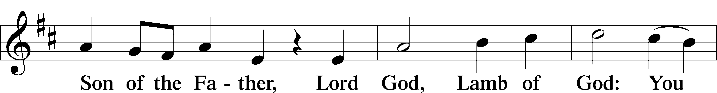
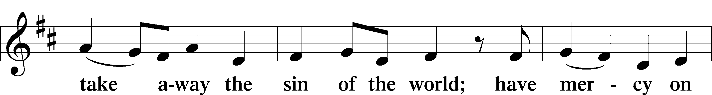
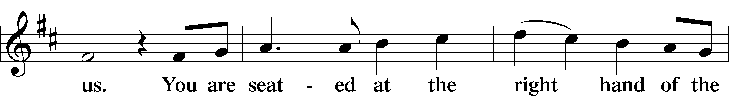
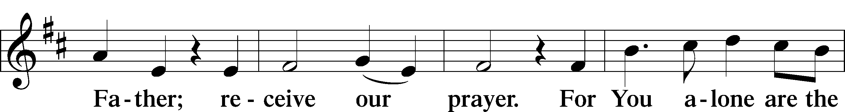
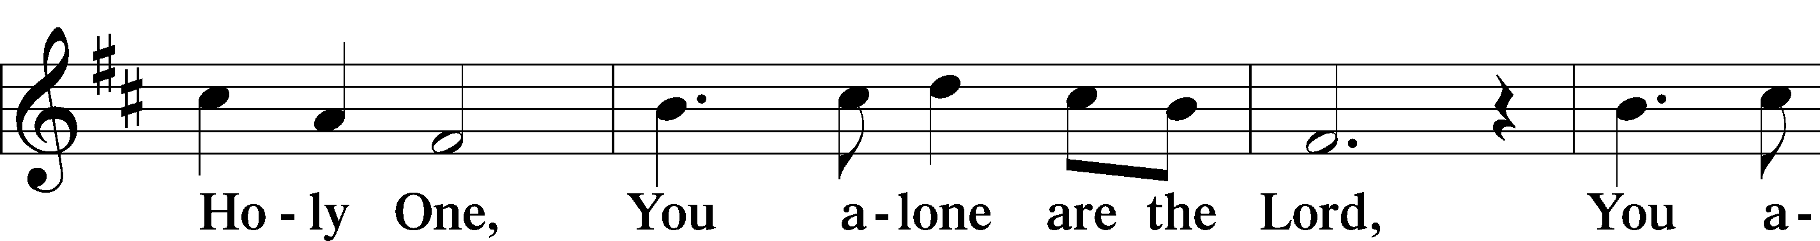
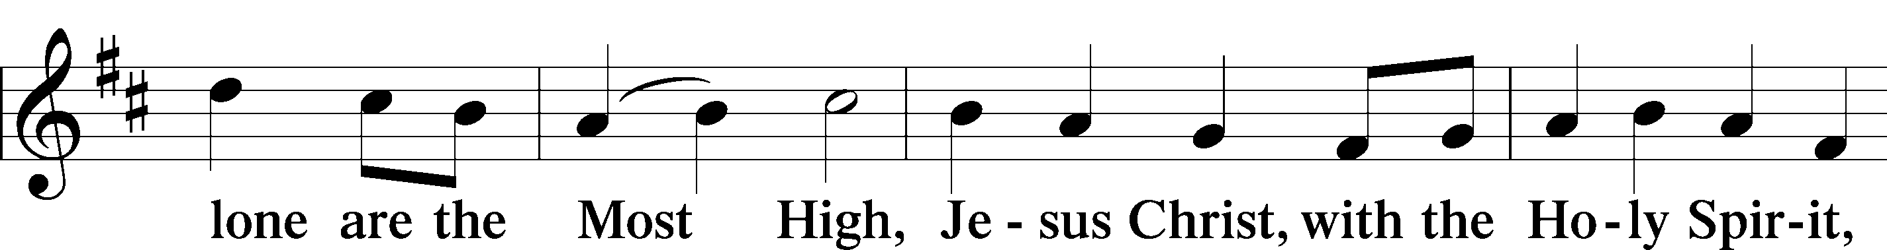
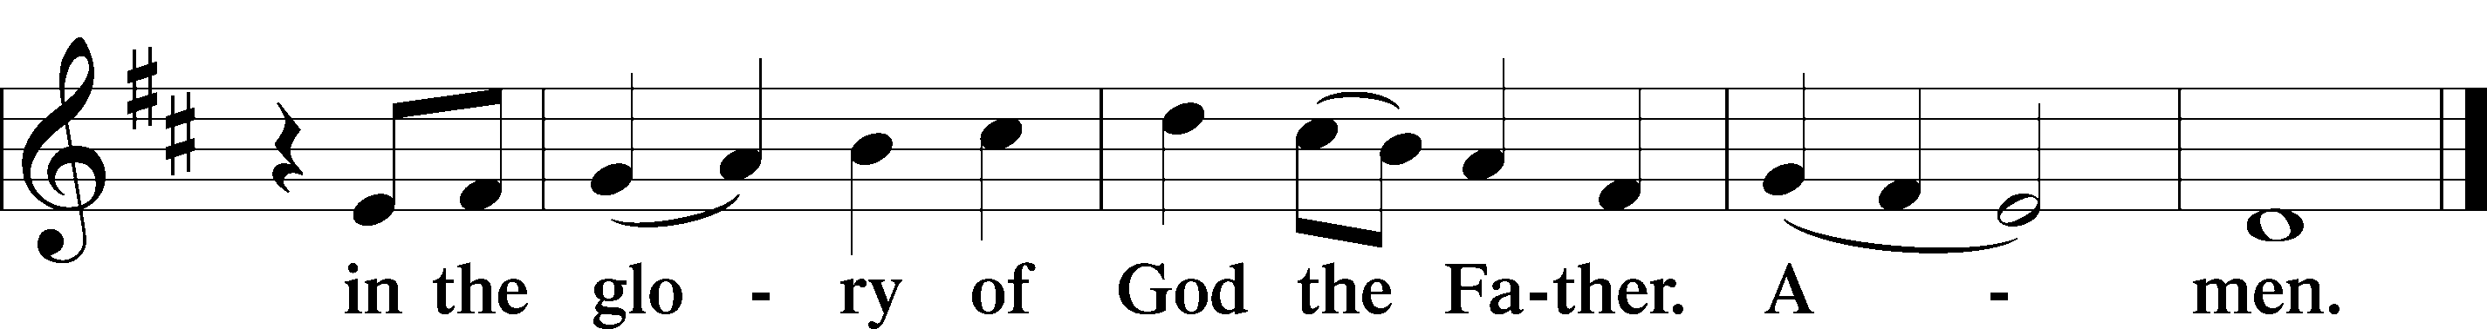

Salutation and Collect of the Day
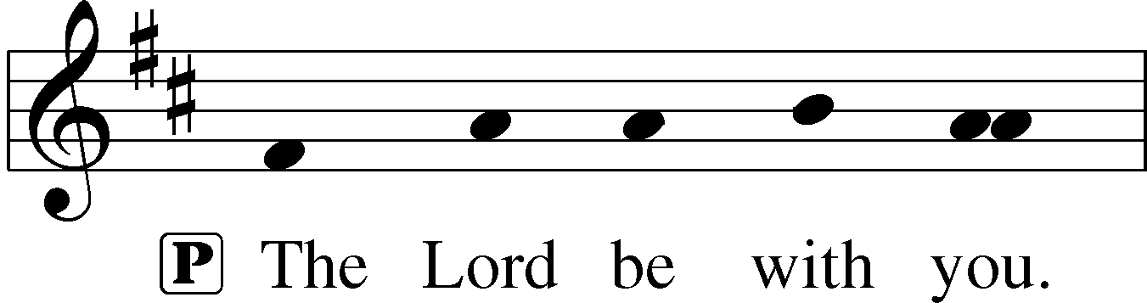
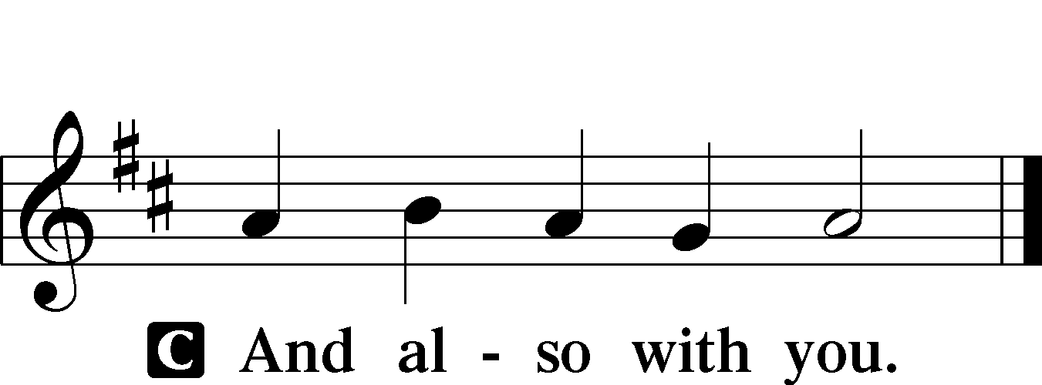

P Let us pray.
Father in heaven, at the Baptism of Jesus in the Jordan River You proclaimed Him Your beloved Son and anointed Him with the Holy Spirit. Make all who are baptized in His name faithful in their calling as Your children and inheritors with Him of everlasting life; through the same Jesus Christ, our Lord, who lives and reigns with You and the Holy Spirit, one God, now and forever.

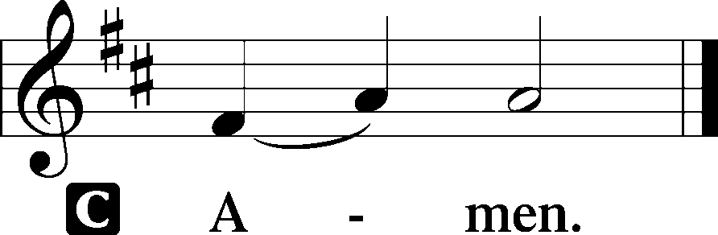

Sit

Old Testament Reading Joshua 3:1–3, 7–8, 13–17
A The Old Testament Reading is from Joshua, chapter 3.

1Then Joshua rose early in the morning and they set out from Shittim. And they came to the Jordan, he and all the people of Israel, and lodged there before they passed over. 2At the end of three days the officers went through the camp 3and commanded the people, “As soon as you see the ark of the covenant of the Lord your God being carried by the Levitical priests, then you shall set out from your place and follow it. . . .
7The Lord said to Joshua, “Today I will begin to exalt you in the sight of all Israel, that they may know that, as I was with Moses, so I will be with you. 8And as for you, command the priests who bear the ark of the covenant, ‘When you come to the brink of the waters of the Jordan, you shall stand still in the Jordan.’” . . .
13“And when the soles of the feet of the priests bearing the ark of the Lord, the Lord of all the earth, shall rest in the waters of the Jordan, the waters of the Jordan shall be cut off from flowing, and the waters coming down from above shall stand in one heap.”
14So when the people set out from their tents to pass over the Jordan with the priests bearing the ark of the covenant before the people, 15and as soon as those bearing the ark had come as far as the Jordan, and the feet of the priests bearing the ark were dipped in the brink of the water (now the Jordan overflows all its banks throughout the time of harvest), 16the waters coming down from above stood and rose up in a heap very far away, at Adam, the city that is beside Zarethan, and those flowing down toward the Sea of the Arabah, the Salt Sea, were completely cut off. And the people passed over opposite Jericho. 17Now the priests bearing the ark of the covenant of the Lord stood firmly on dry ground in the midst of the Jordan, and all Israel was passing over on dry ground until all the nation finished passing over the Jordan.

A This is the Word of the Lord.
C Thanks be to God.

Psalm Psalm 85; antiphon: v. 9
1Lord, you were favorable | to your land;*
you restored the fortunes of | Jacob.
2You forgave the iniquity of your | people;*
you covered | all their sin.
3You withdrew | all your wrath;*
you turned from your hot | anger.
4Restore us again, O God of our sal- | vation,*
and put away your indignation | toward us!
5Will you be angry with us for- | ever?*
Will you prolong your anger to all gener- | ations?
6Will you not revive | us again,*
that your people may re- | joice in you?
7Show us your steadfast love, | O Lord,*
and grant us your sal- | vation.
8Let me hear what God the | Lord will speak,*
for he will speak peace to his people, to his saints;
but let them not turn back to | folly.
9Surely his salvation is near to those who | fear him,*
that glory may dwell | in our land.
10Steadfast love and faith- | fulness meet;*
righteousness and peace kiss each | other.
11Faithfulness springs up | from the ground,*
and righteousness looks down | from the sky.
12Yes, the Lord will give | what is good,*
and our land will yield its | increase.
13Righteousness will go be- | fore him*
and make his foot- | steps a way.
Epistle 1 Corinthians 1:26–31
A The Epistle is from 1 Corinthians, chapter 1.

26For consider your calling, brothers: not many of you were wise according to worldly standards, not many were powerful, not many were of noble birth. 27But God chose what is foolish in the world to shame the wise; God chose what is weak in the world to shame the strong; 28God chose what is low and despised in the world, even things that are not, to bring to nothing things that are, 29so that no human being might boast in the presence of God. 30He is the source of your life in Christ Jesus, whom God made our wisdom and our righteousness and sanctification and redemption. 31Therefore, as it is written, “Let the one who boasts, boast in the Lord.”

A This is the Word of the Lord.
C Thanks be to God.

Stand

Alleluia and Verse
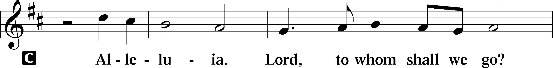
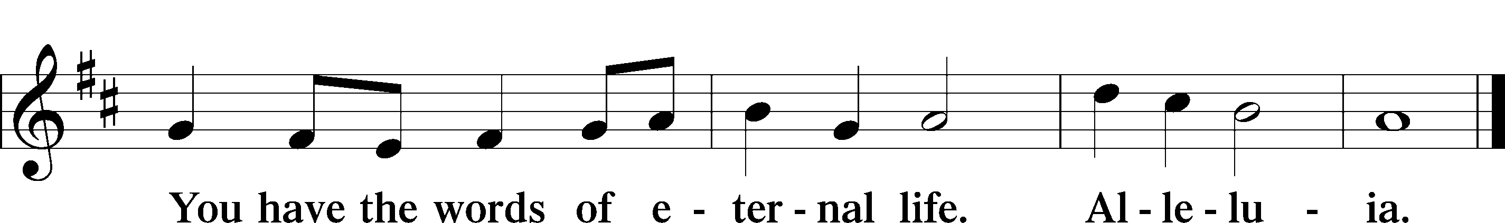

Holy Gospel St. Matthew 3:13–17
P The Holy Gospel according to St. Matthew, the third chapter.

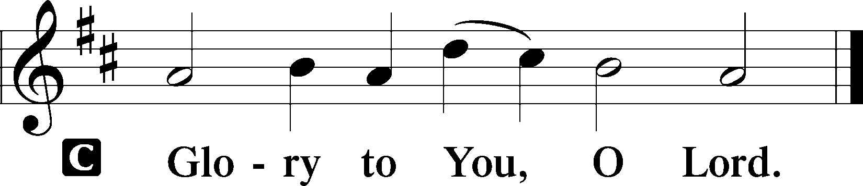

13Then Jesus came from Galilee to the Jordan to John, to be baptized by him. 14John would have prevented him, saying, “I need to be baptized by you, and do you come to me?” 15But Jesus answered him, “Let it be so now, for thus it is fitting for us to fulfill all righteousness.” Then he consented. 16And when Jesus was baptized, immediately he went up from the water, and behold, the heavens were opened to him, and he saw the Spirit of God descending like a dove and coming to rest on him; 17and behold, a voice from heaven said, “This is my beloved Son, with whom I am well pleased.”

P This is the Gospel of the Lord.

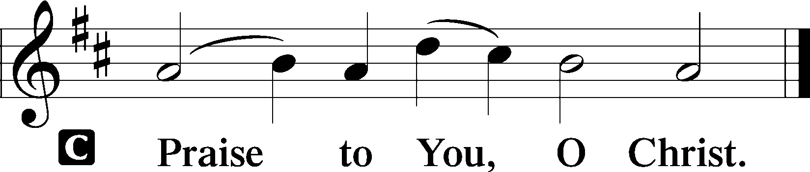

Sit

Sermon

Stand

From God the Father, Virgin Born Hymn of the Day
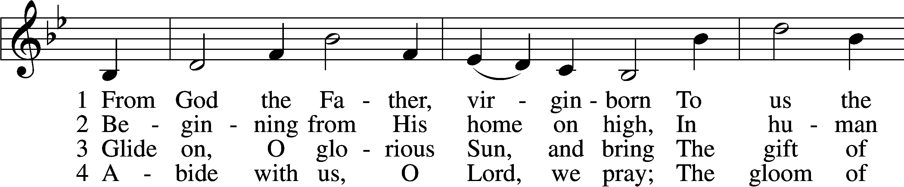
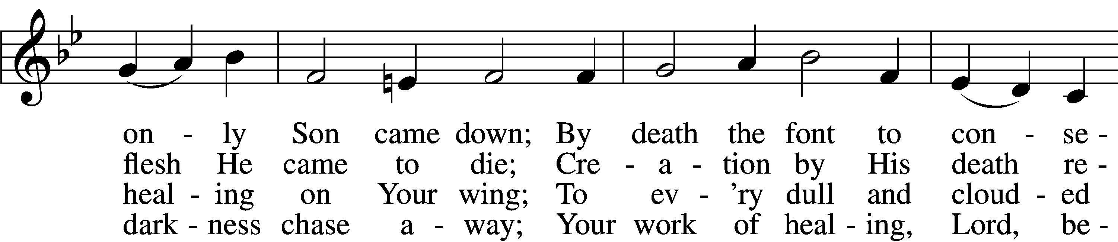
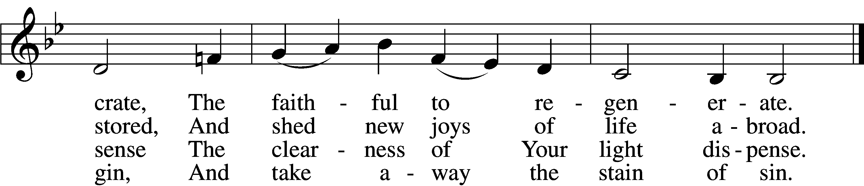
Text and tune: Public domain

Nicene Creed
C We believe in one God,
the Father, the Almighty,
maker of heaven and earth
of all that is, seen and unseen.

We believe in one Lord, Jesus Christ,
the only Son of God,
eternally begotten of the Father,
God from God, Light from Light,
true God from true God,
begotten, not made,
of one Being with the Father.
Through him all things were made.
For us and for our salvation
he came down from heaven;
by the power of the Holy Spirit
he became incarnate from the Virgin Mary,
and was made man.
For our sake he was crucified under Pontius Pilate;
he suffered death and was buried.
On the third day He rose again
in accordance with the Scriptures;
he ascended into heaven
and is seated at the right hand of the Father.
He will come again in glory to judge the living and the dead,
and his kingdom will have no end.

We believe in the Holy Spirit, the Lord, the giver of life,
who proceeds from the Father and the Son.
With the Father and the Son he is worshiped and glorified.
He has spoken by the prophets.
We believe in one holy catholic and apostolic Church,
We acknowledge one Baptism for the forgiveness of sins,
We look for the resurrection of the dead,
and the life T of the world to come. Amen.

Prayer of the Church

Sit

SERVICE OF THE SACRAMENT

A hymn is sung while the ministers prepare the altar for the Holy Communion.

Jesus Shall Reign sts. 1–2, 4–5
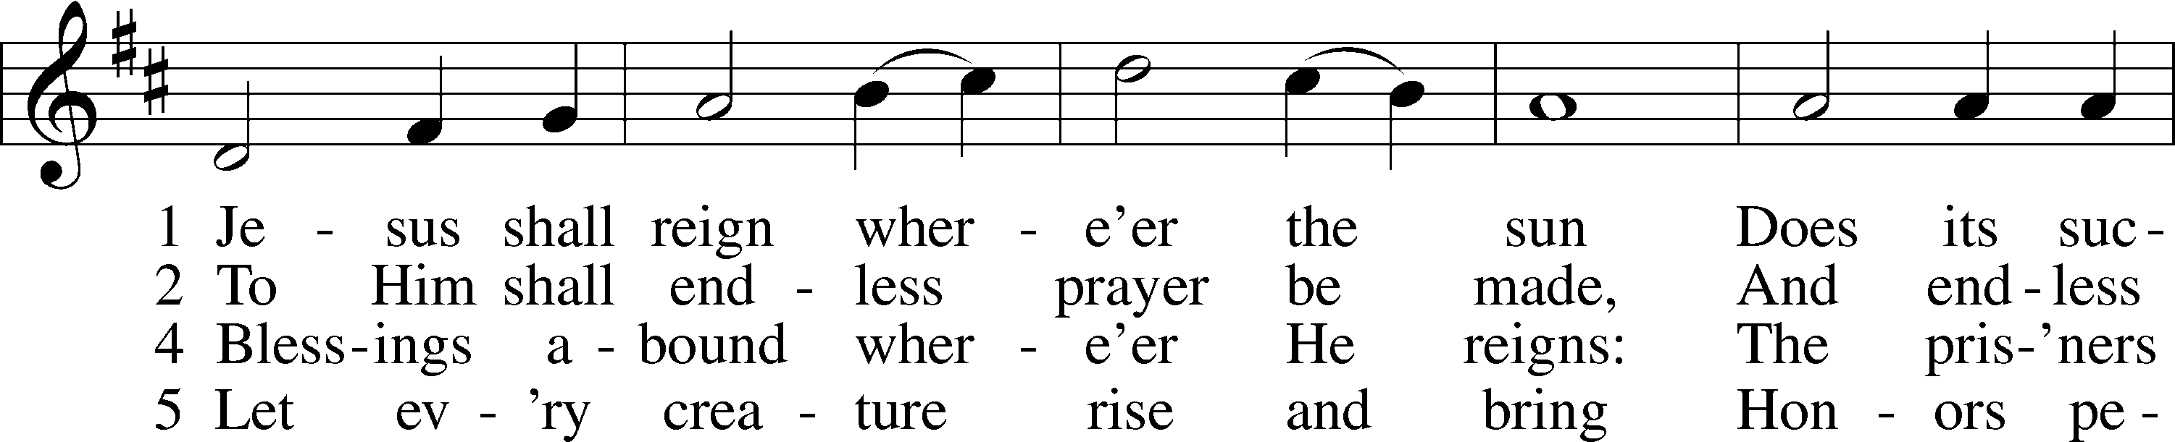
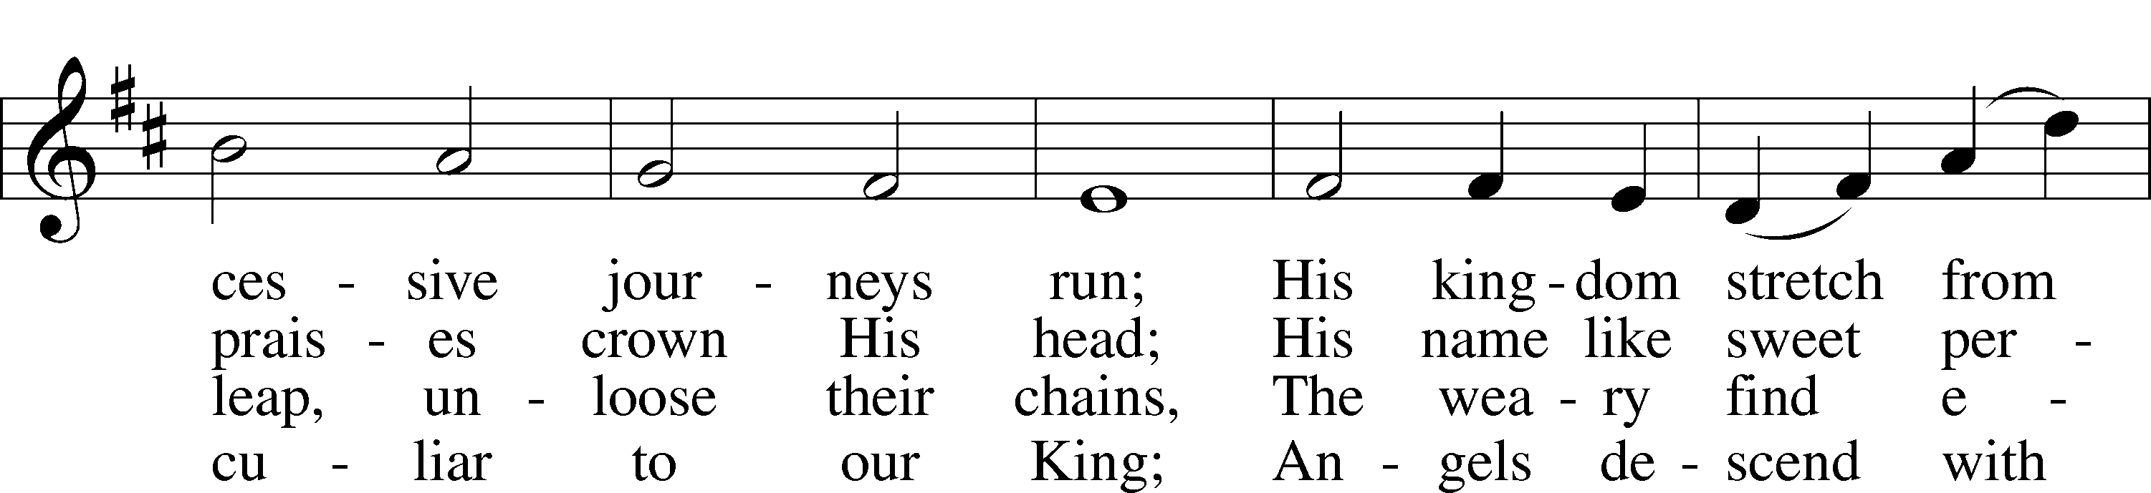
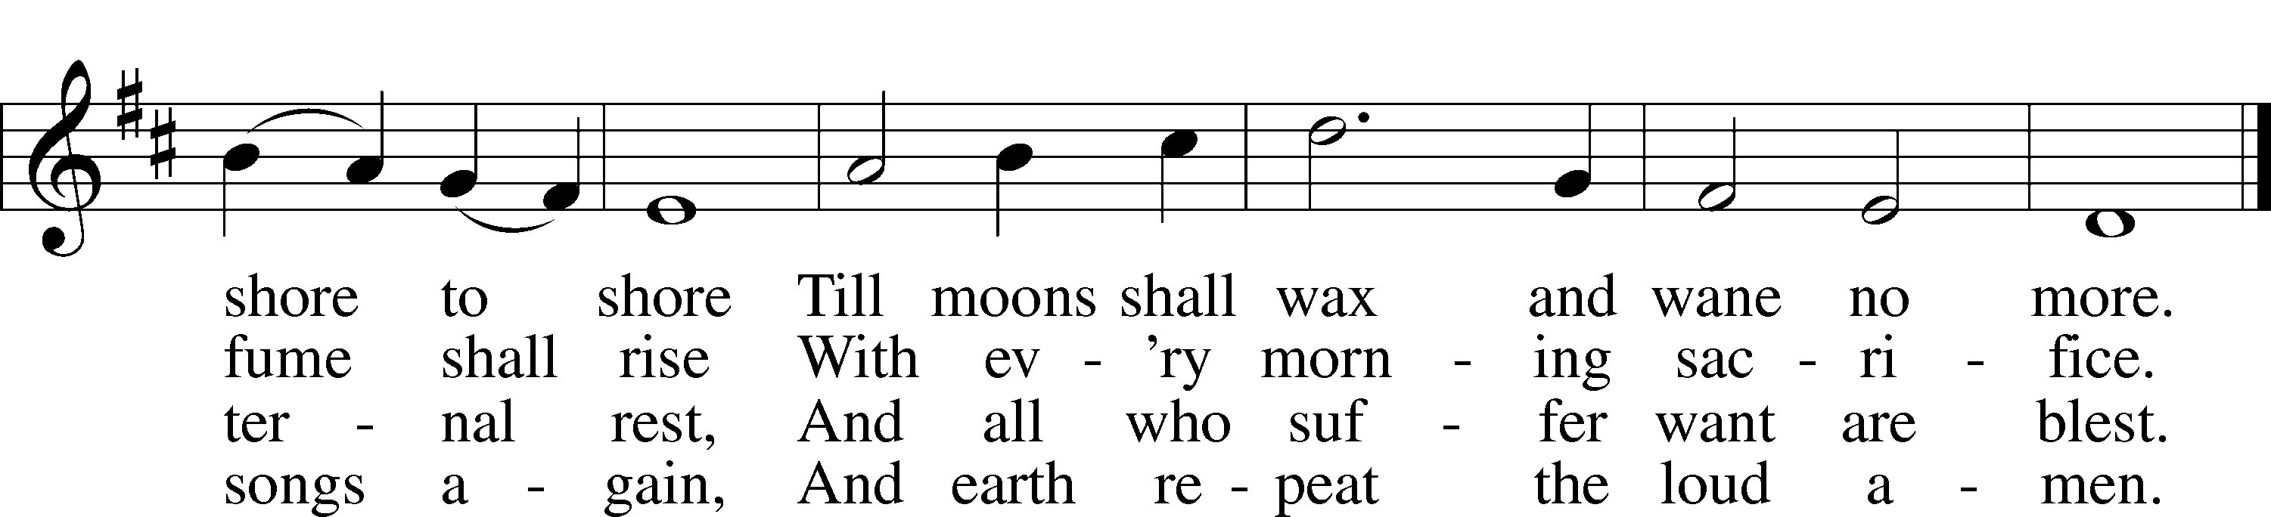
Tune and text: Public domain

After the altar has been prepared, we stand for the Offertory.

Offertory
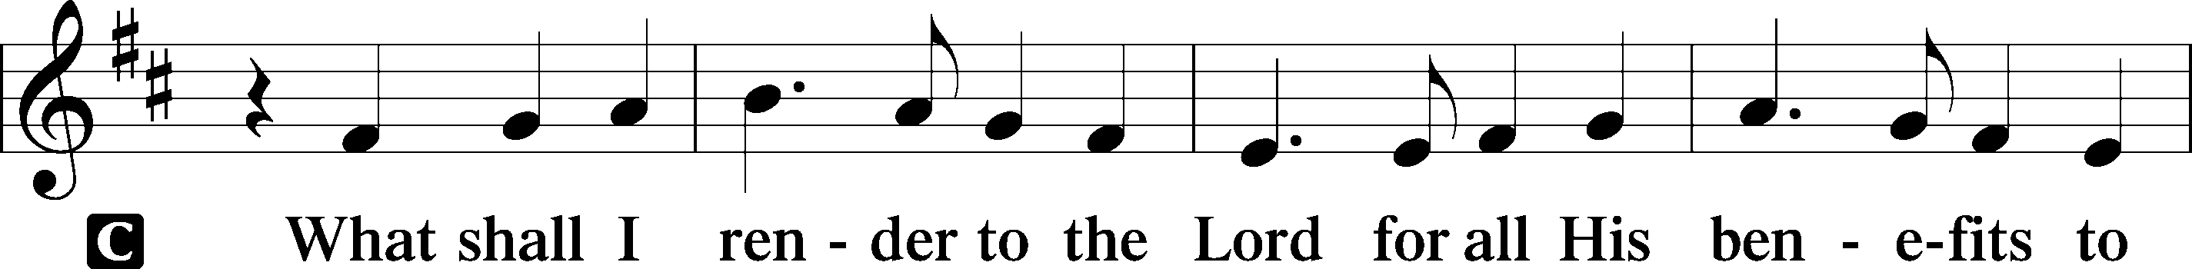
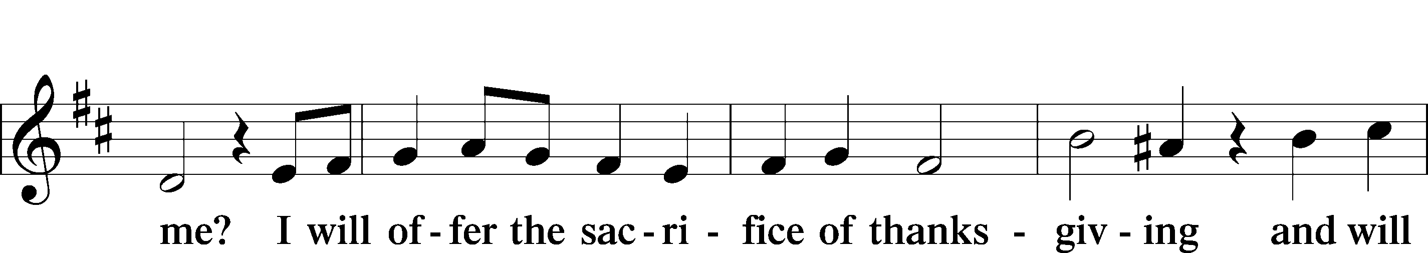
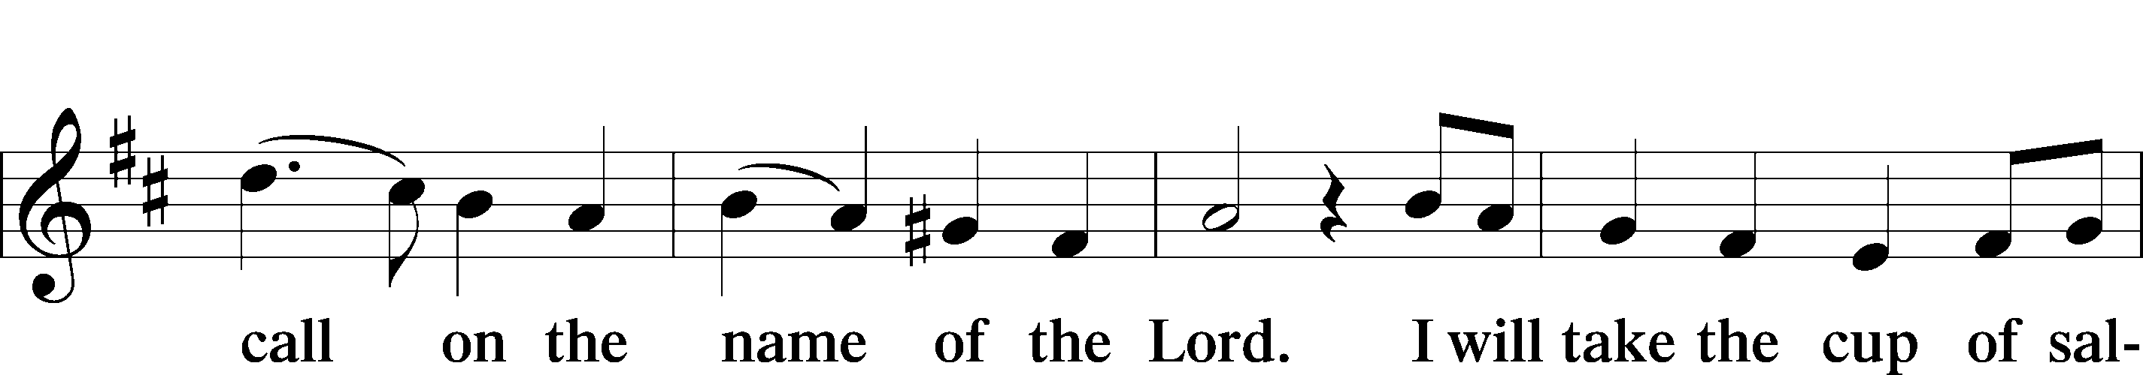
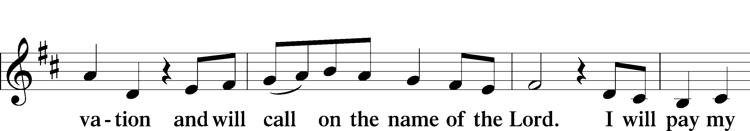
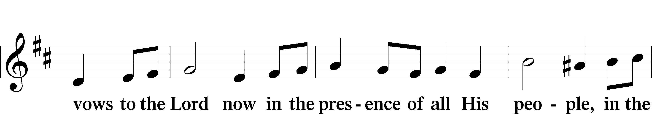
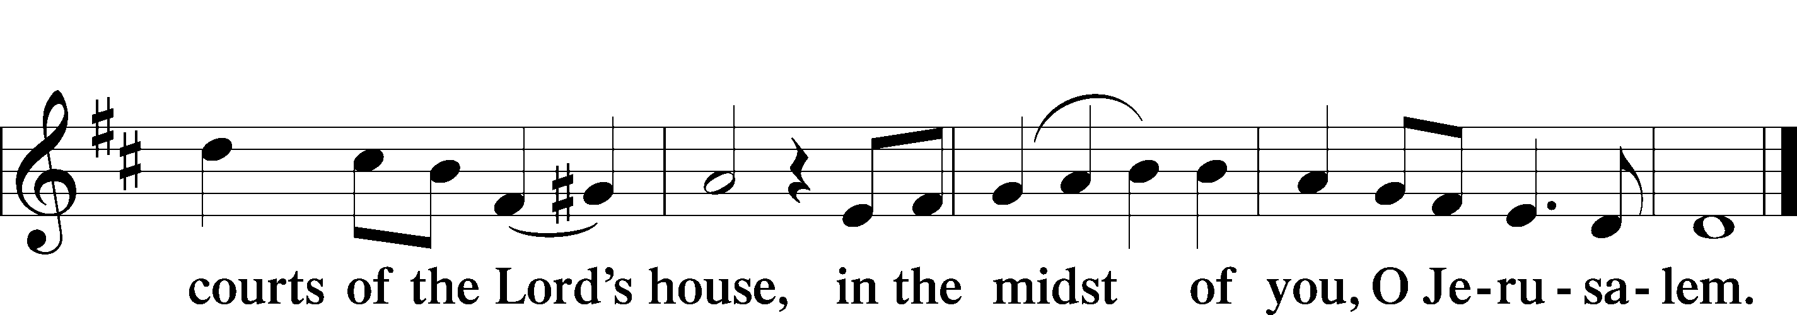

Offertory Prayer
P Merciful Father,
C We offer with joy and thanksgiving, what You have first given us: our selves, our time, and our possessions – signs of Your gracious love. Receive them for the sake of Him Who offered Himself for us, Jesus Christ, our Lord. Amen.

Preface
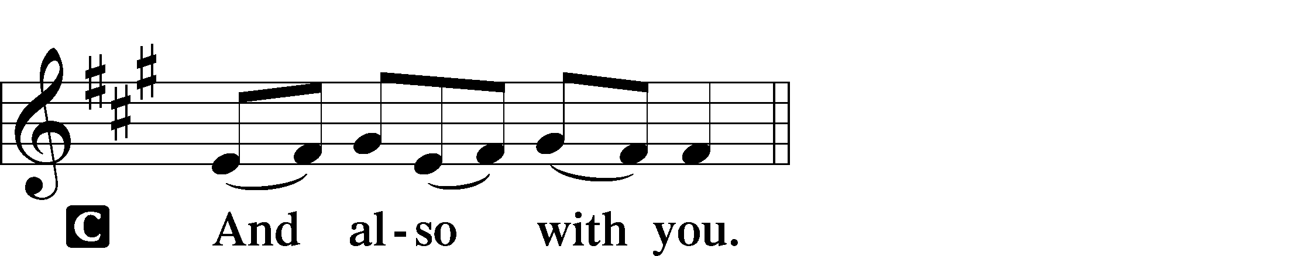
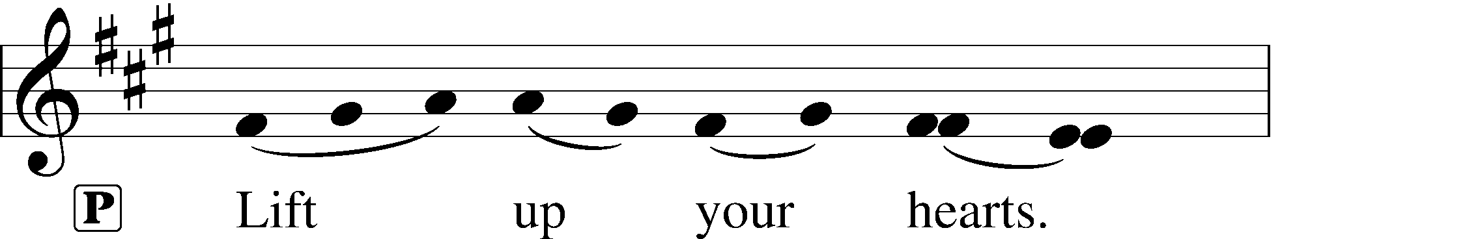
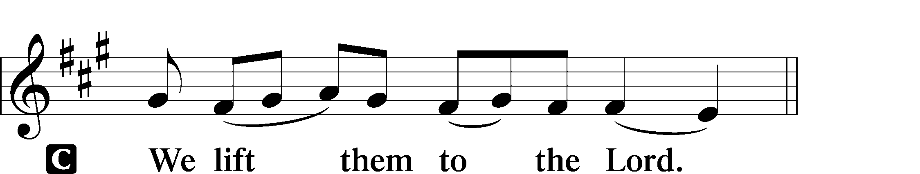

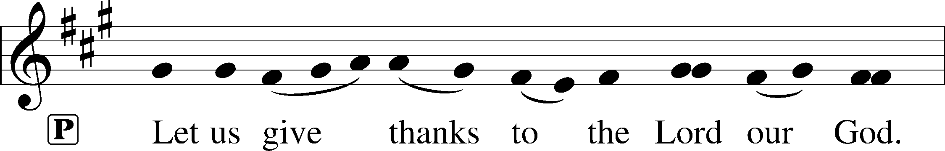
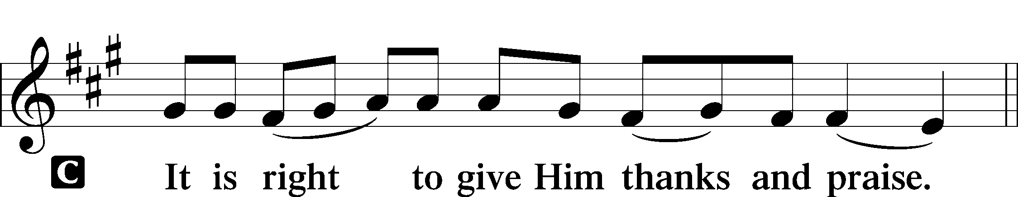

Proper Preface

Sanctus
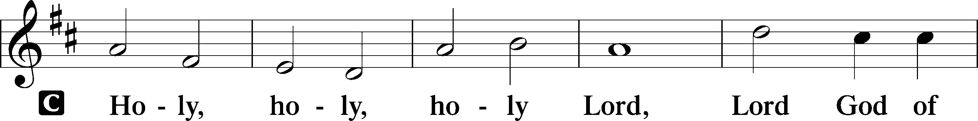
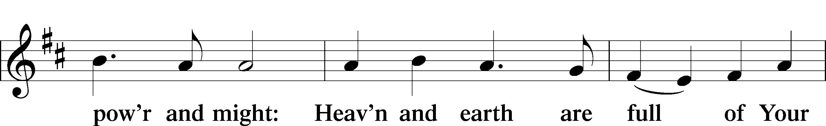
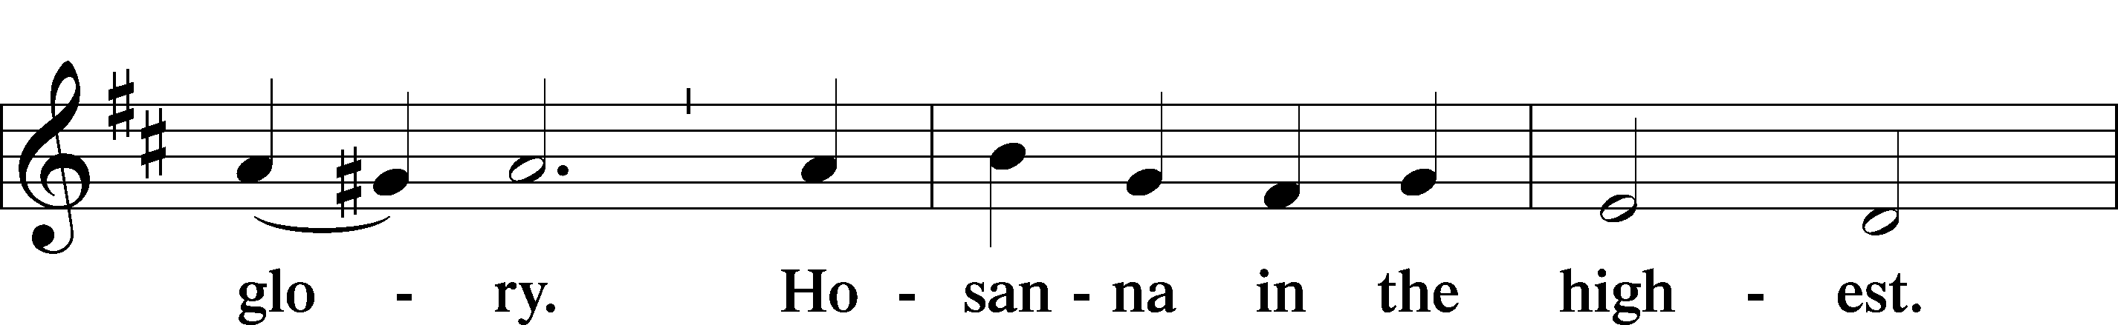
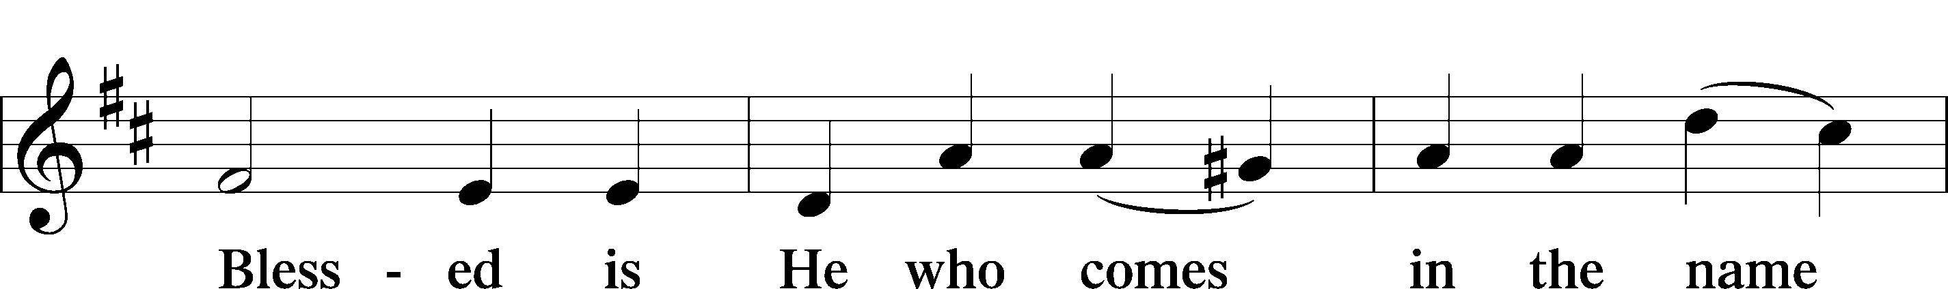
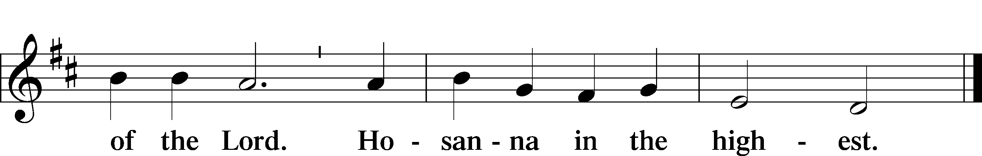

Prayer of Thanksgiving
P Most holy Father, as the glory of Your presence once filled Your ancient temple, so in the incarnation of Your Son, Jesus Christ, You manifested the fullness of Your glory in human flesh. We give You thanks that in His most Holy Supper You reveal Your mercy to us. Grant us faithfully to eat His body and drink His blood so that we may one day behold Your glory face to face.

C Amen.

The Words of Our Lord

Proclamation of Christ
P As often as we eat this bread and drink this cup, we proclaim the Lord’s death until He comes.
C Amen. Come, Lord Jesus.

P O Lord Jesus Christ, only Son of the Father, in giving us Your body and blood to eat and to drink, You lead us to remember and confess Your holy cross and passion, Your blessed death, Your rest in the tomb, Your resurrection from the dead, Your ascension into heaven, and Your coming for the final judgment. So remember us in Your kingdom and teach us to pray:

The Lord’s Prayer

Pax Domini
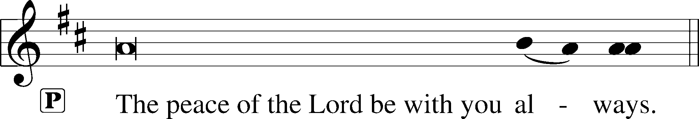

Sit

Agnus Dei
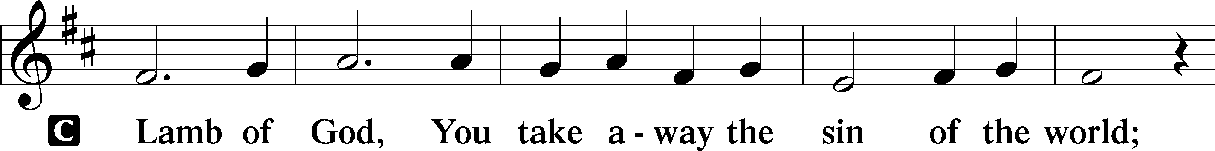
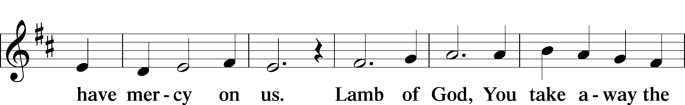
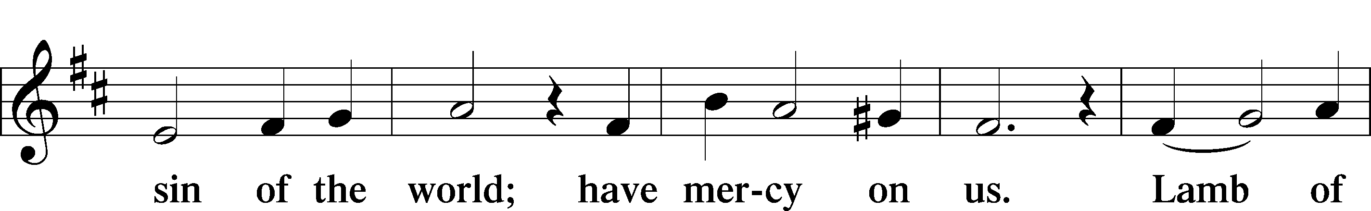
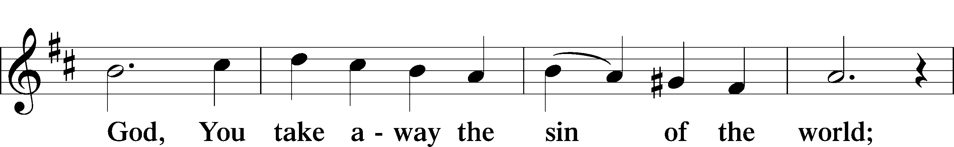
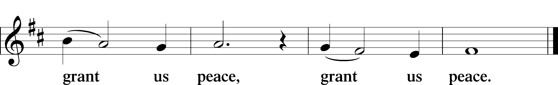

The congregation comes forward to receive the Lord's body and blood at the credence table before the steps.

Distribution

The following hymns are sung during the Distribution of Holy Communion.

Communion Hymn LBW 452

Communion Hymn LBW 203

After all have Communed and returned to their pews, we stand for the Post-Communion Blessing.

Blessing

Post-Communion Canticle
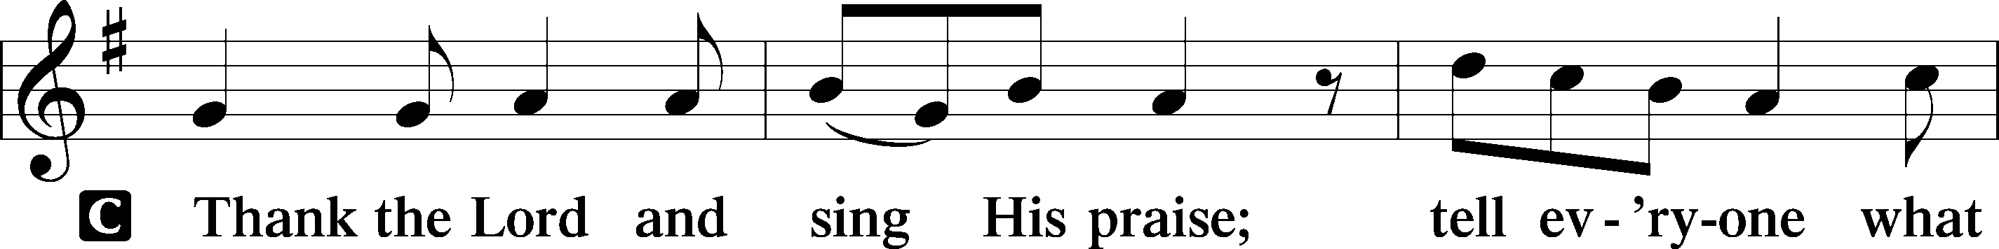
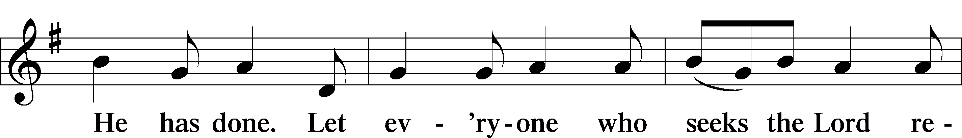
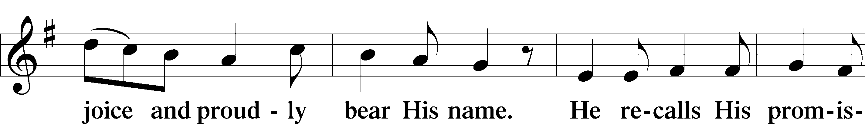
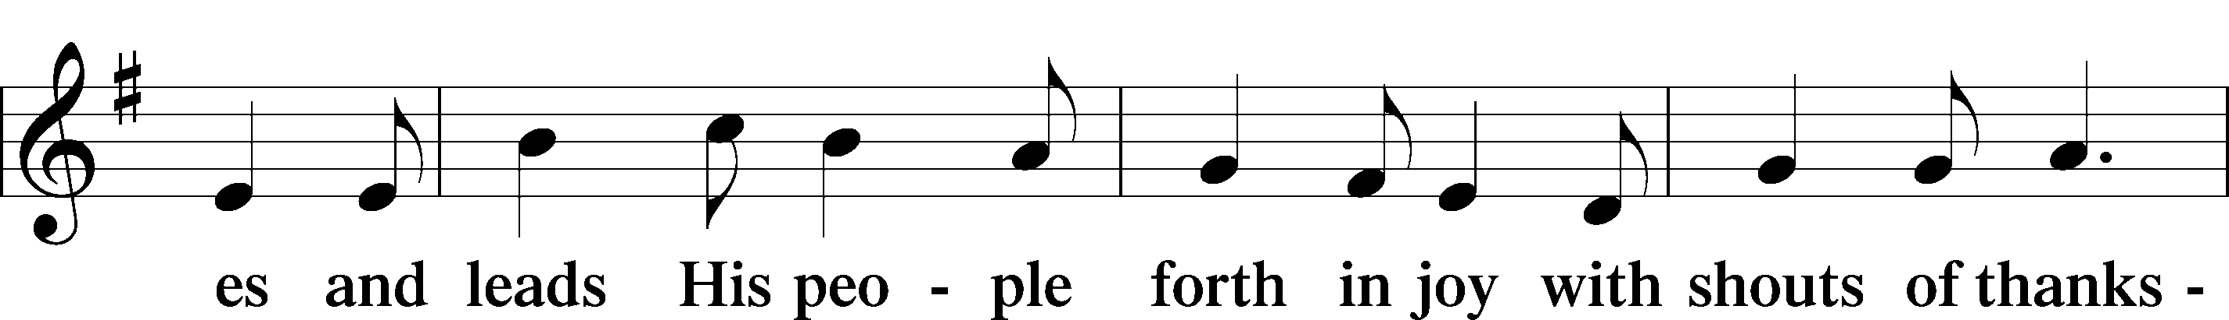
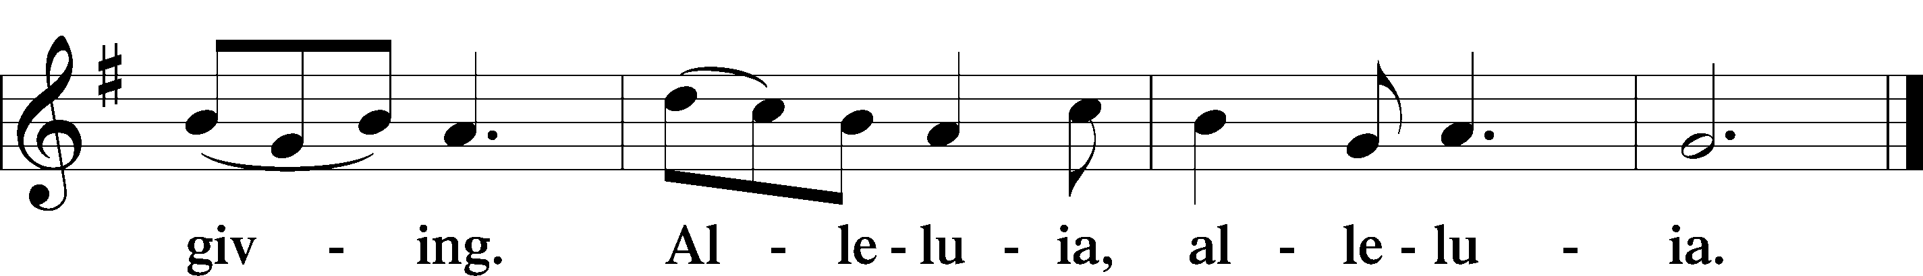

Post-Communion Collect
A Let us pray.
We give thanks to You, almighty God, that You have refreshed us through this salutary gift, and we implore You that of Your mercy You would strengthen us through the same in faith toward You and in fervent love toward one another; through Jesus Christ, Your Son, our Lord, who lives and reigns with You and the Holy Spirit, one God, now and forever.
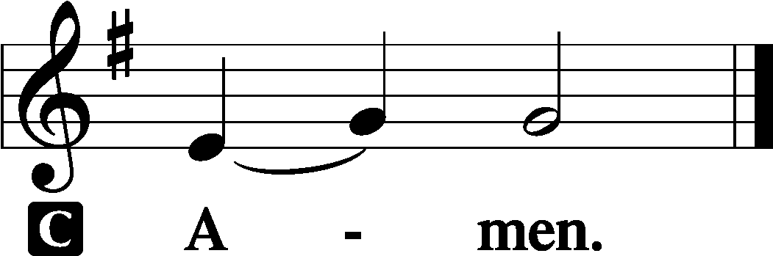

Benediction
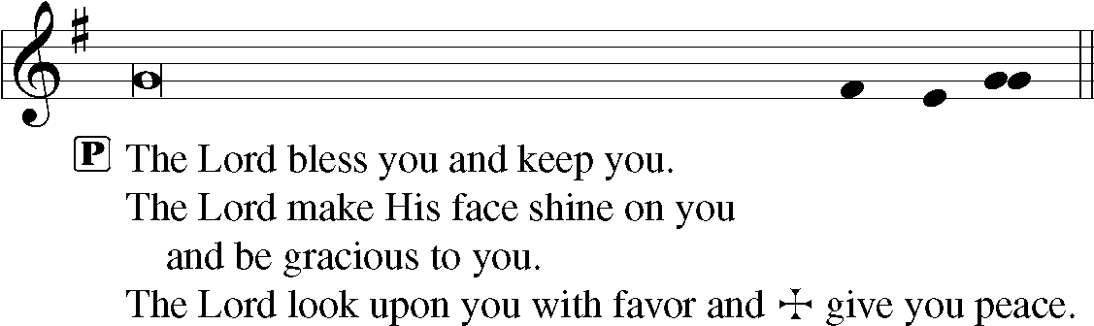

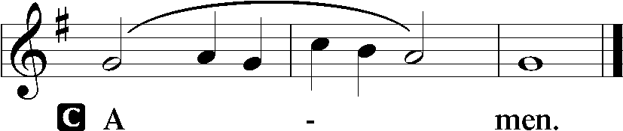

Guide Me, O Thou Great Redeemer Mission Hymn
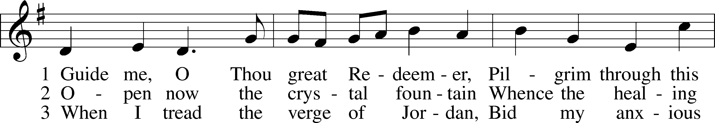
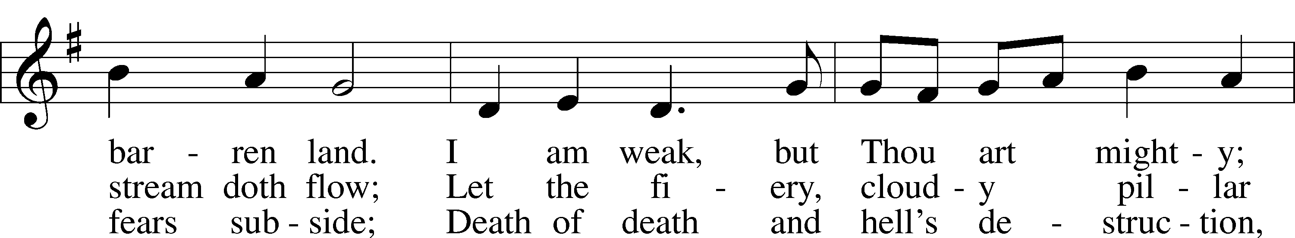
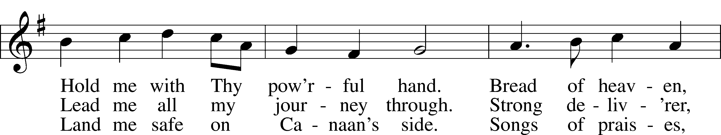
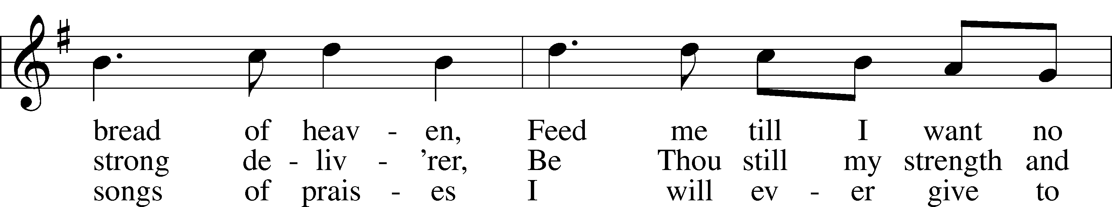
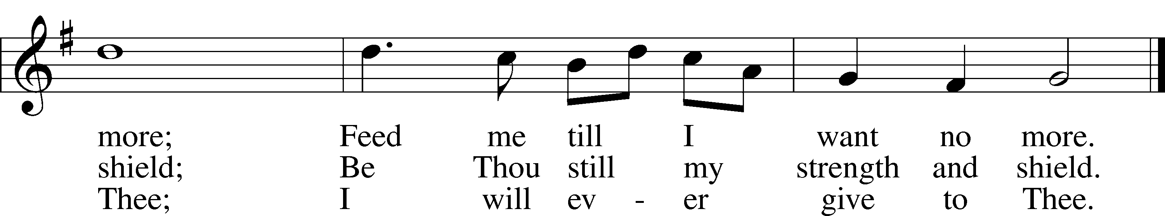
Text and tune: Public domain

Dismissal

The congregation may remain for silent prayer.

Acknowledgments
Unless otherwise indicated, Scripture quotations are from the ESV® Bible (The Holy Bible, English Standard Version®), copyright © 2001 by Crossway, a publishing ministry of Good News Publishers. Used by permission. All rights reserved.
Created by Lutheran Service Builder © 2021 Concordia Publishing House.

PRAYER REQUESTS

Nadine Buckle, Bessie and Annie Clem, Debbie Gochenour, Kelliann Harris, Howard McDonald, Lola McDonald, Andrea Oxsen, Ernie Pingley, Bill Rose, the family of Densil Rickard, and all caregivers.

GENERAL ANNOUNCEMENTS

Zoom Meetings this week:
Monday 10am – A History of Heresy
Monday 7pm – Revelation Study
Contact Pastor Chris for more information.

Communion Service Wednesdays at 11am.

Pastor Chris will be available on Wednesdays, 10:30am – 3pm for Communions. Please call for an appointment.

The Outreach Committee will meet on Thursday at 6pm. The Church Council will meet at 7pm.

PARISH INFORMATION

Lebanon Lutheran Church
540.465.5456
lebanonlutheranchurch.org
10120 Middle Rd.
Lebanon Church, VA 22641

Pastor Porter
Mobile: 248.794.2263

Church Secretary
secretary2.lebanon@gmail.com

