Service of Light

Stand

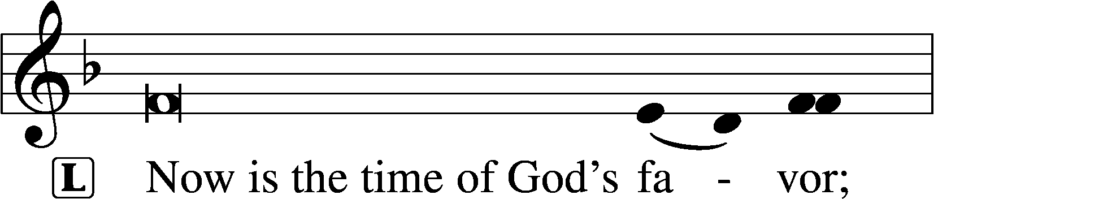
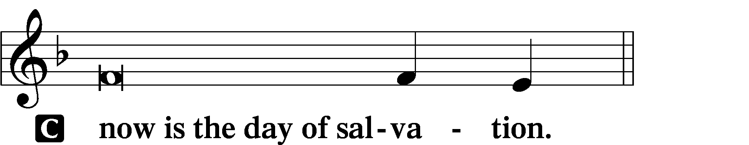

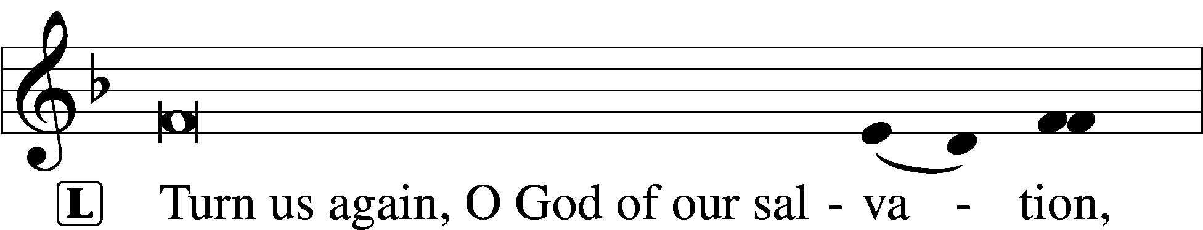
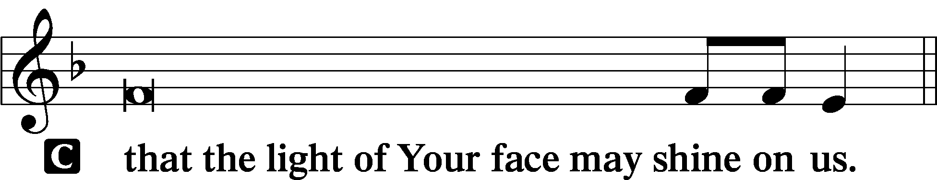

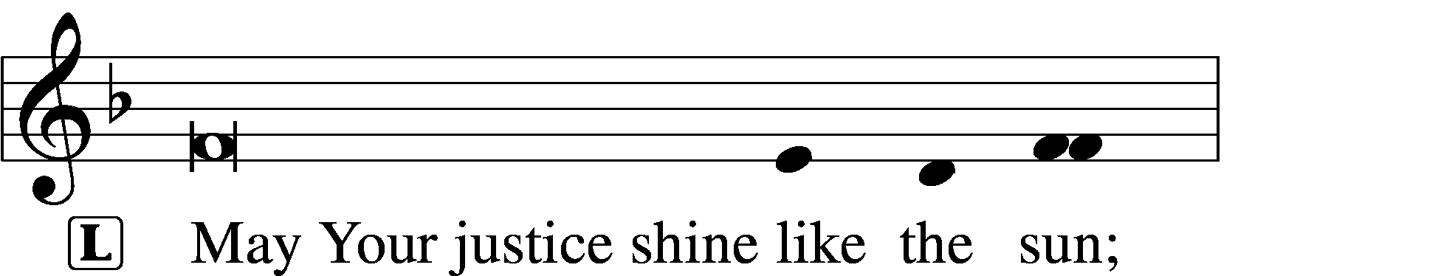
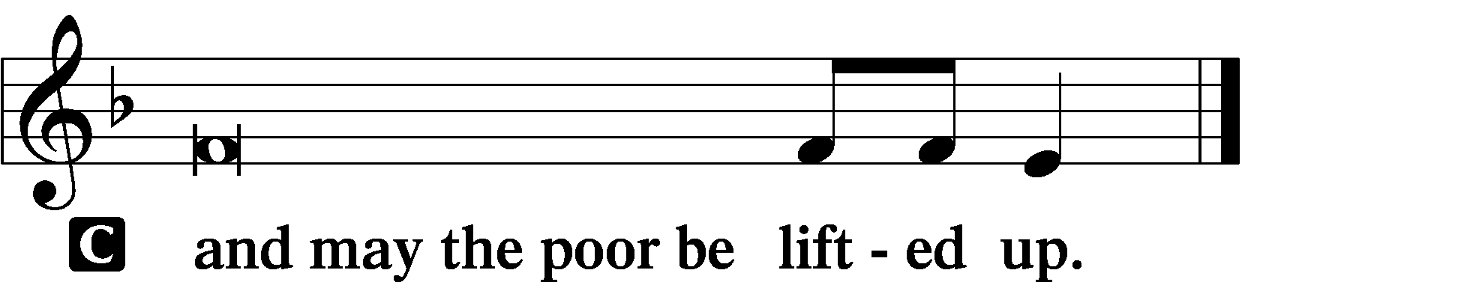

Phos Hilaron LSB 244
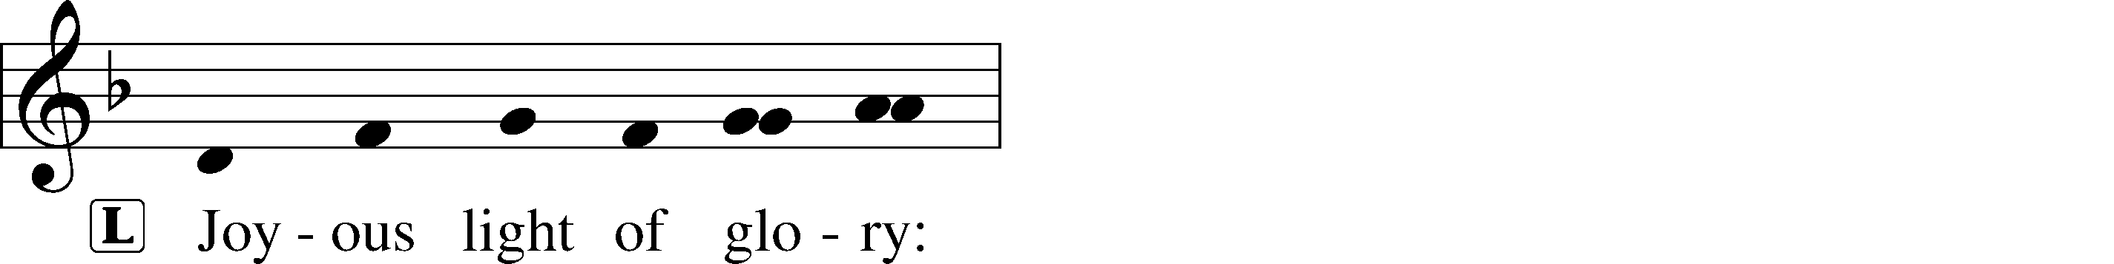
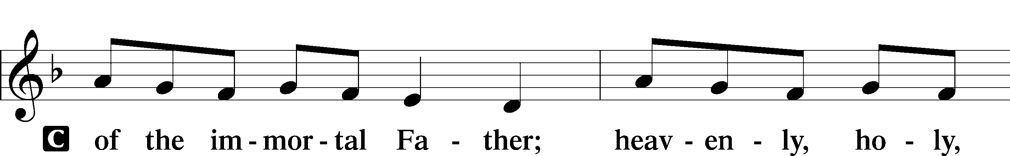
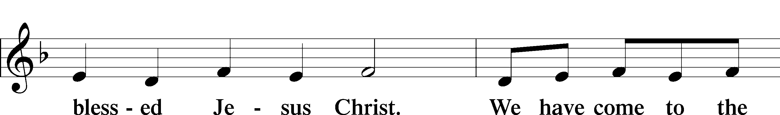
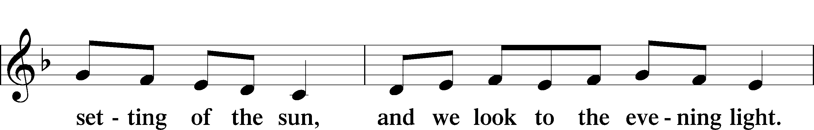
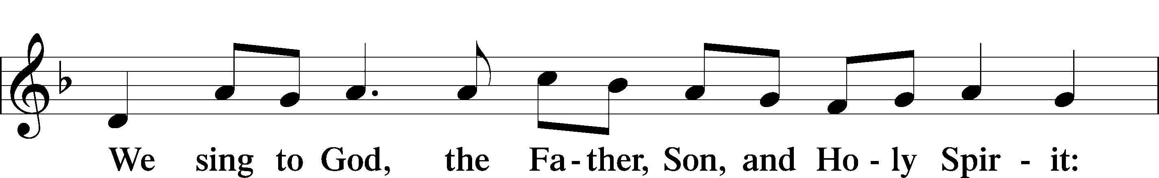
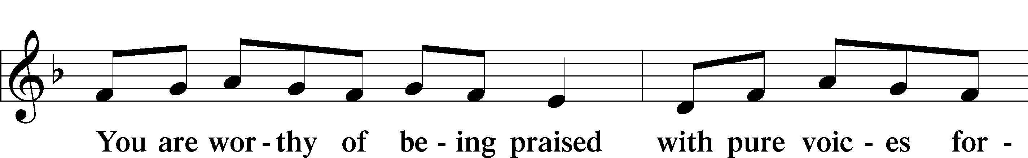
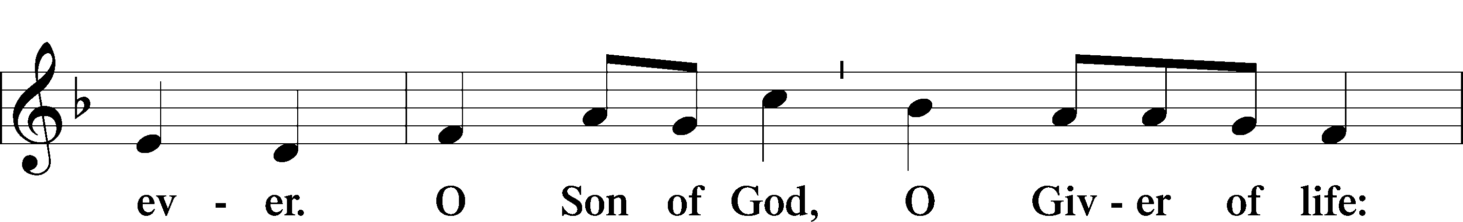
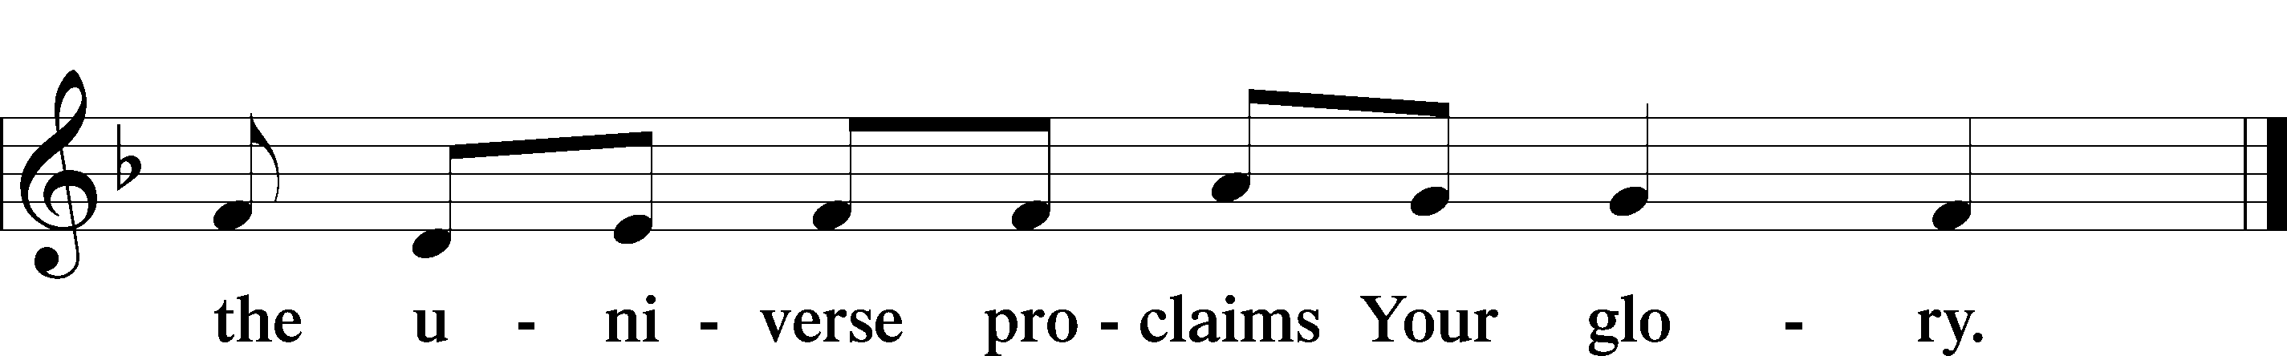

Thanksgiving for Light LSB 245
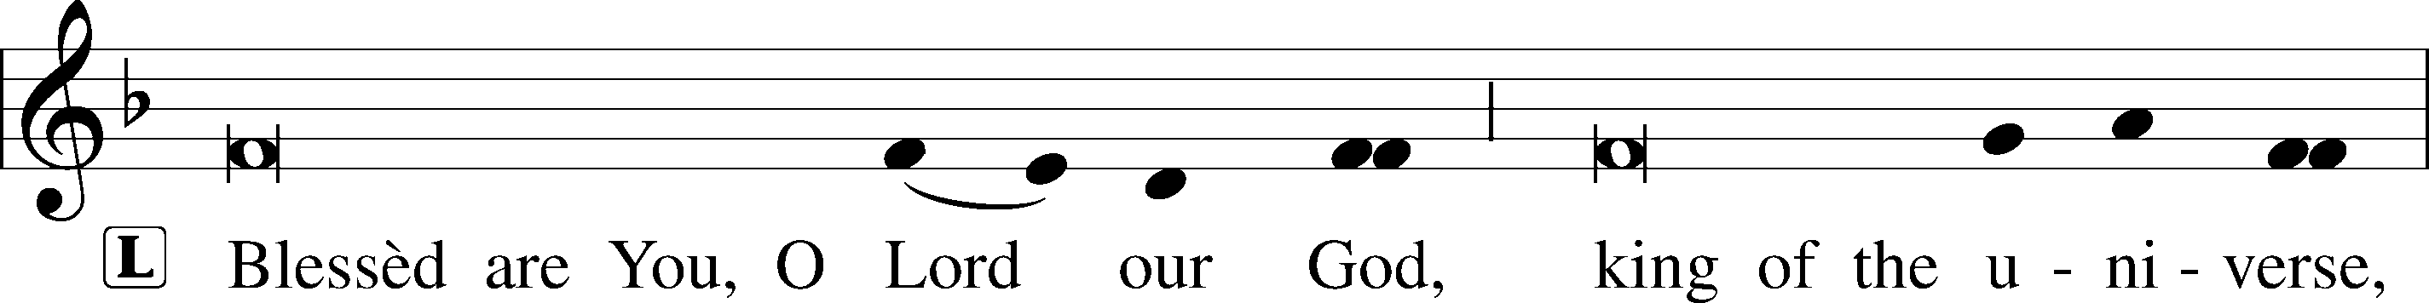
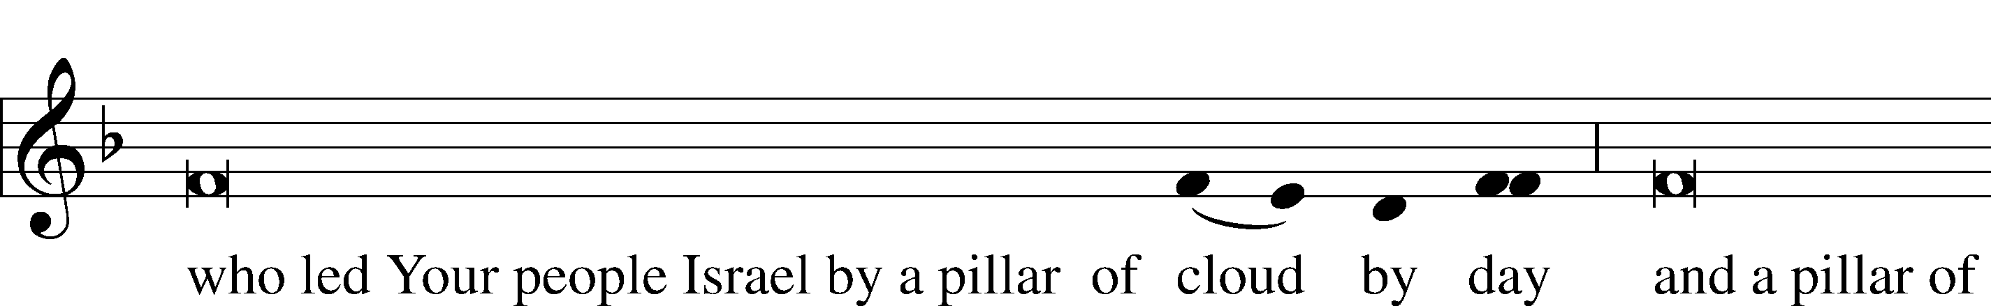
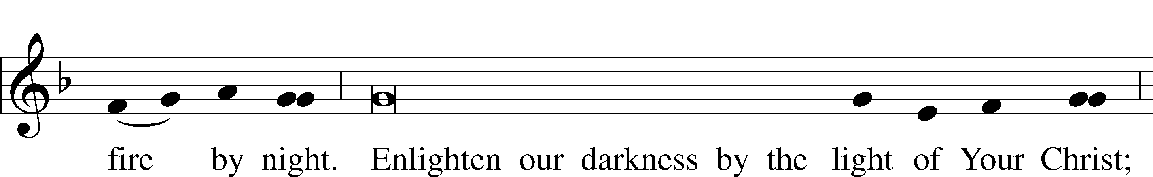
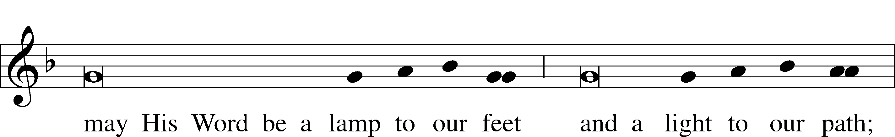
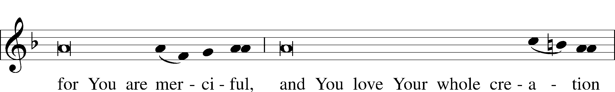
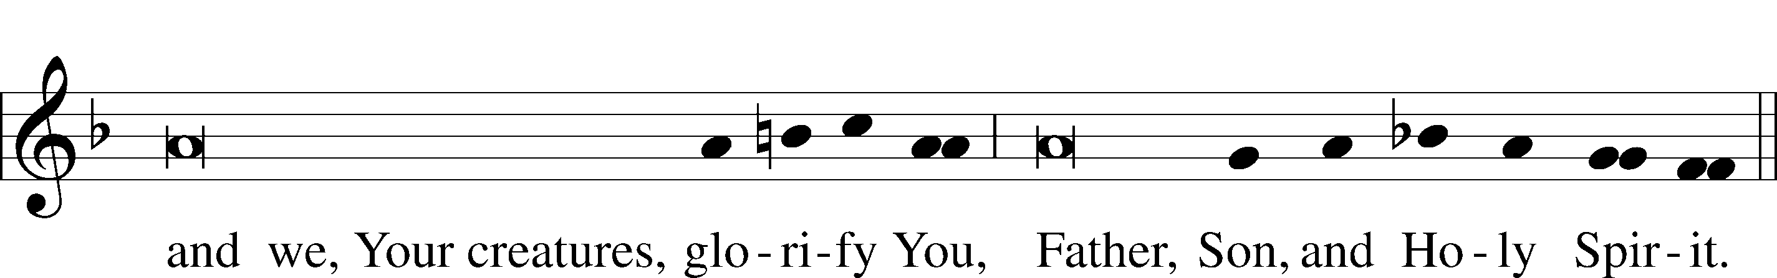

Sit

Psalmody

Psalm 141 LSB 245
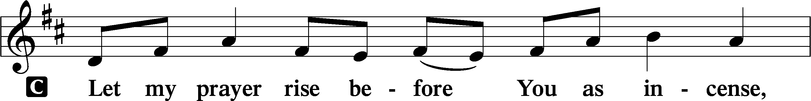
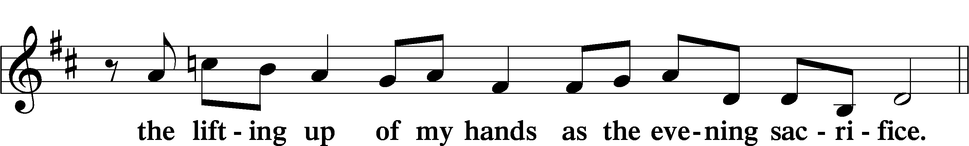
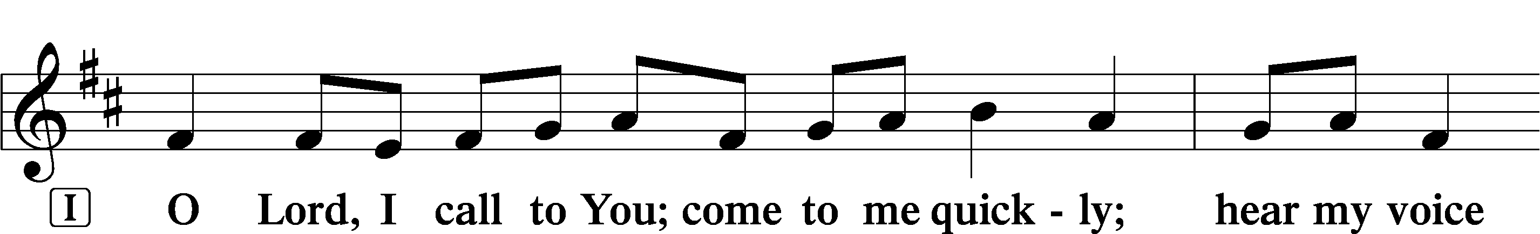
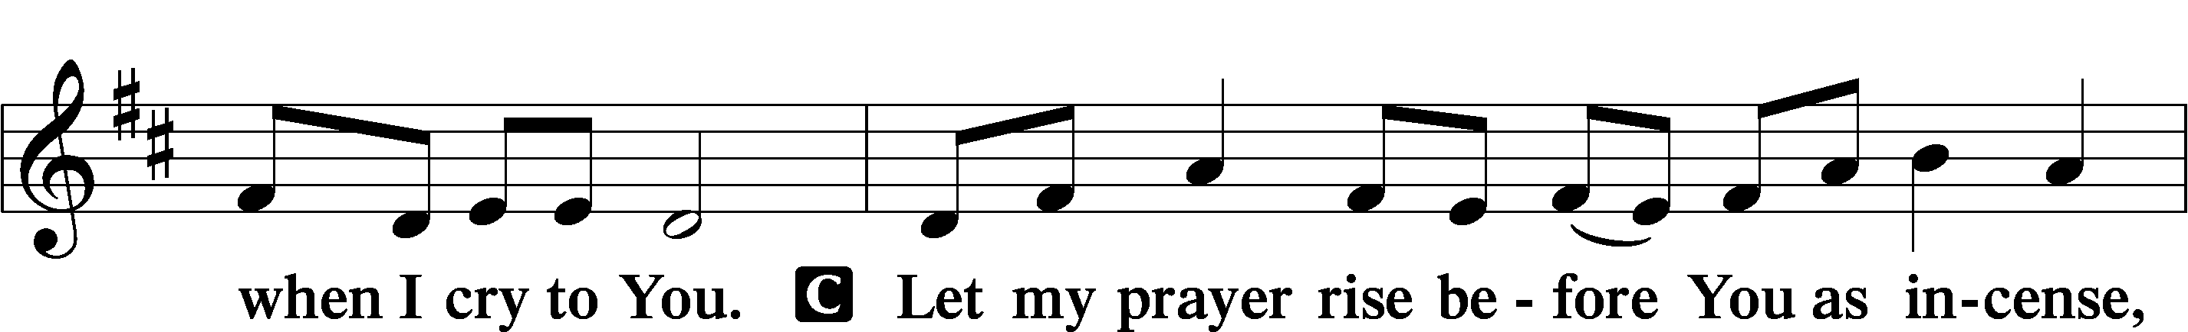
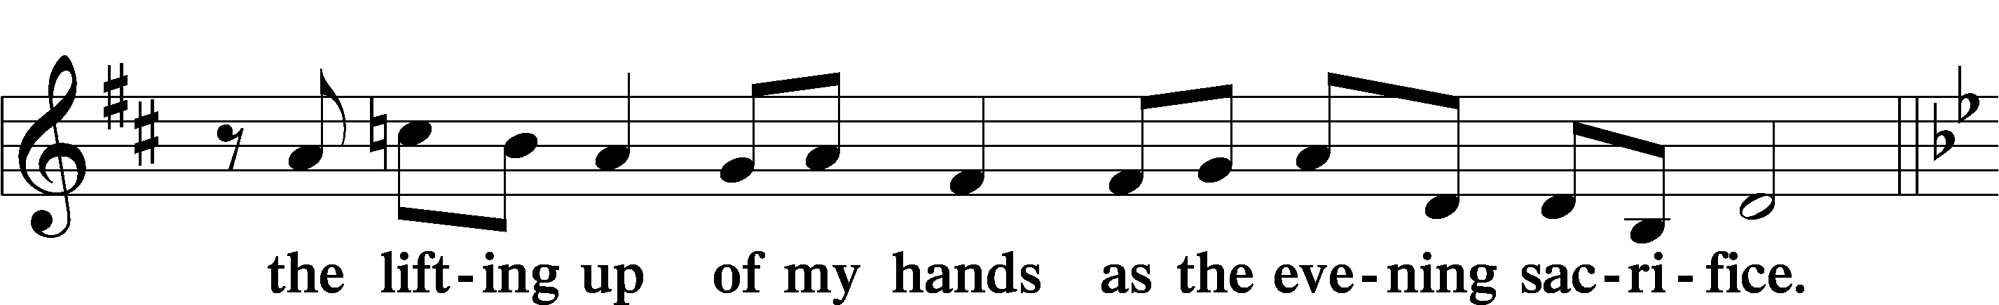
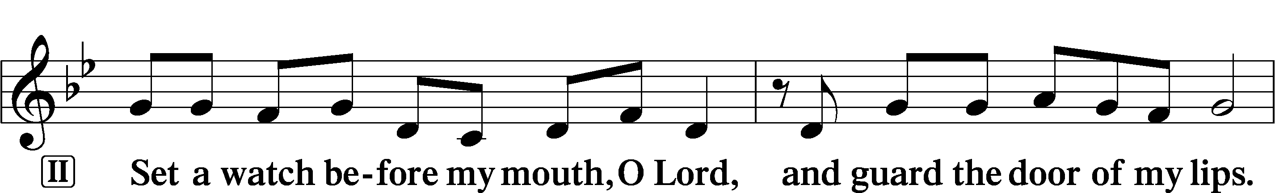
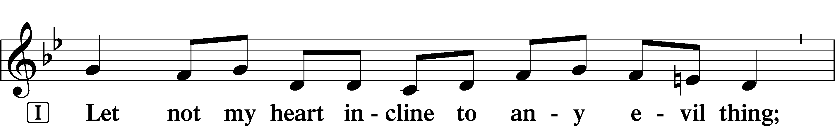
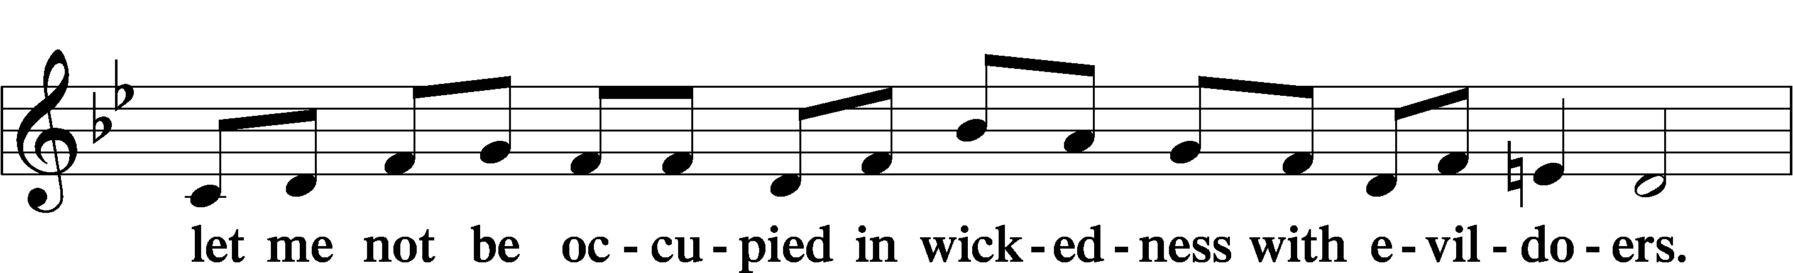
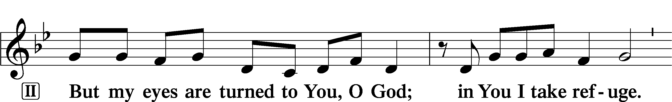
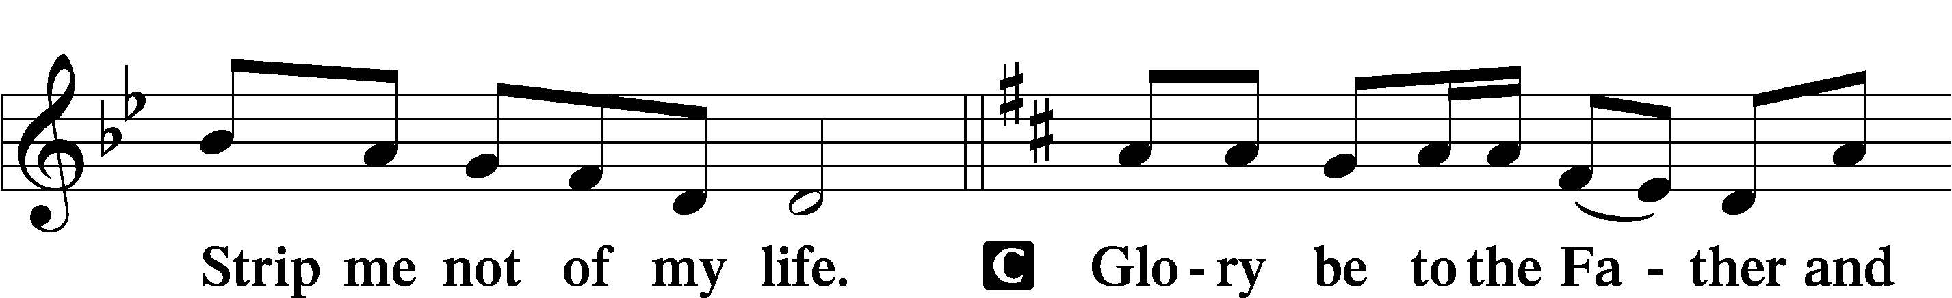
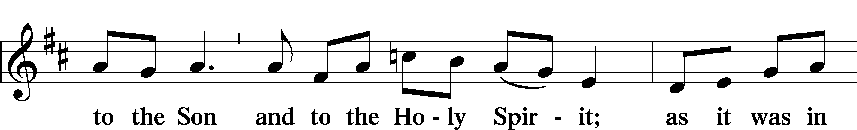
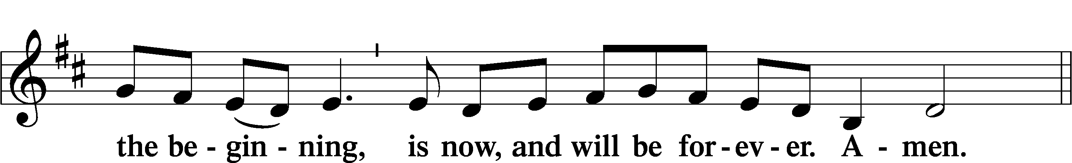
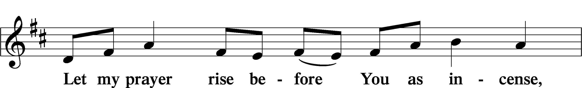
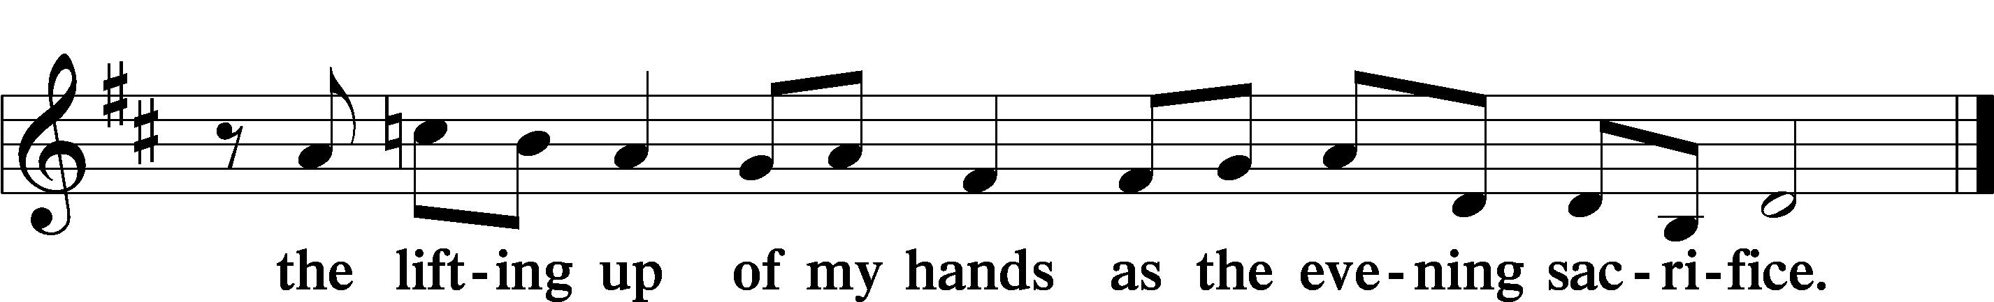

L Let us pray.
Let the incense of our repentant prayer ascend before You, O Lord, and let Your loving-kindness descend on us that, with purified minds, we may sing Your praises with the Church on earth and the whole heavenly host and may glorify You forever.
C Amen.

624 The Infant Priest Was Holy Born
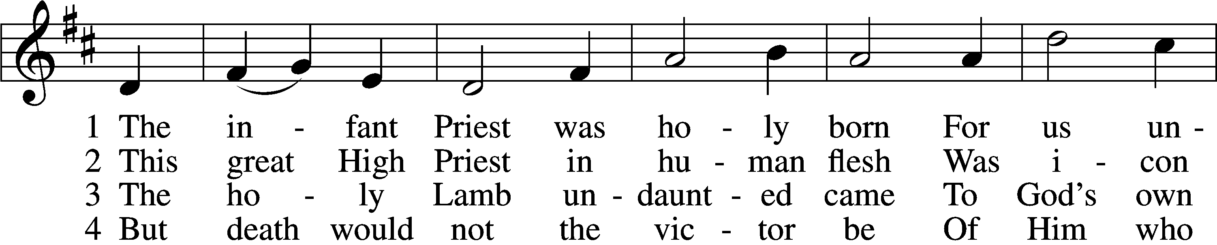
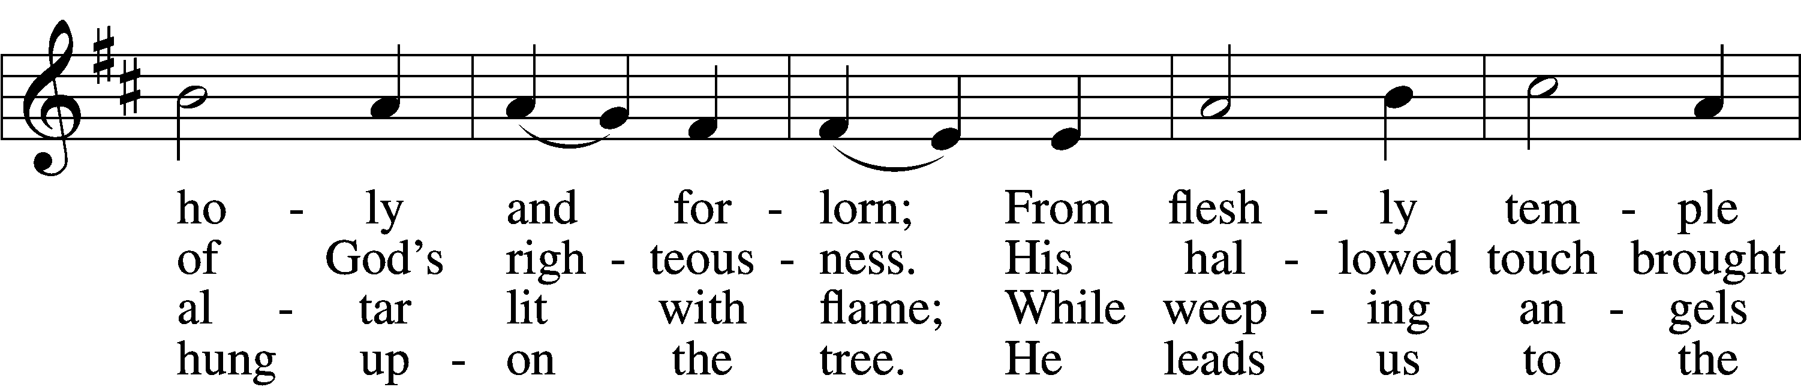
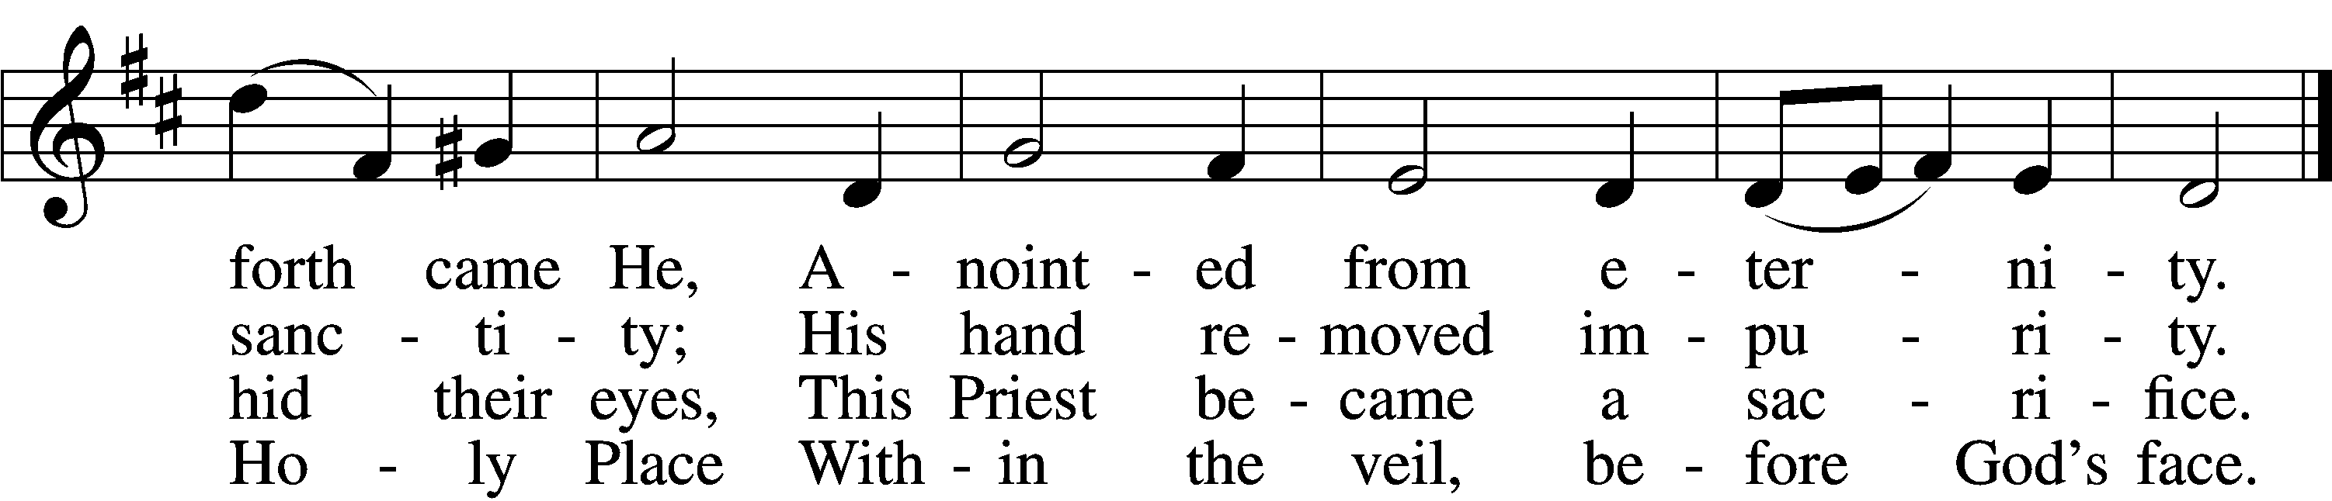

5 The veil is torn, our Priest we see,
As at the rail on bended knee
Our hungry mouths from Him receive
The bread of immortality.

6 The body of God’s Lamb we eat,
A priestly food and priestly meat;
On sin-parched lips the chalice pours
His quenching blood that life restores.

7 With cherubim and seraphim
Our voices join the endless hymn,
And “Holy, holy, holy” sing
To Christ, God’s Lamb, our Priest and King.
Text: © 1997, 2003 Chad L. Bird. Used by permission: LSB Hymn License no. 130301202
Tune: Public domain

Readings

Reading Hebrews 10:4–10
4For it is impossible for the blood of bulls and goats to take away sins.
5Consequently, when Christ came into the world, he said,
“Sacrifices and offerings you have not desired,
but a body have you prepared for me;
6in burnt offerings and sin offerings
you have taken no pleasure.
7Then I said, ‘Behold, I have come to do your will, O God,
as it is written of me in the scroll of the book.’”
8When he said above, “You have neither desired nor taken pleasure in sacrifices and offerings and burnt offerings and sin offerings” (these are offered according to the law), 9then he added, “Behold, I have come to do your will.” He abolishes the first in order to establish the second. 10And by that will we have been sanctified through the offering of the body of Jesus Christ once for all.

Reading Apology of the Augsburg Confession XXIV
16 In the Phaedrus of Plato, Socrates says that he is especially fond of distinctions, because without these nothing in speech can either be explained or understood. If he discovers anyone skilful in making distinctions, he says that he pays attention and follows his footsteps as those of a god. (He instructs the one to separate the parts of speech in their very joints. So like an inept cook, he breaks some part of speech to pieces.) But the adversaries truly hate these basic rules and, according to Plato, are truly poor butchers. For they break the parts of “sacrifice.” This can be understood when we have listed the kinds of sacrifice. 17 Theologians are rightly familiar with distinguishing between a Sacrament and a sacrifice. Therefore, let them be subdivided into either a ceremony or a sacred work. 18 A Sacrament is a ceremony or work in which God presents to us what the promise of the ceremony offers. Baptism is not a work that we offer to God. It is a work in which God baptizes us. In other words, a minister baptizes us on God’s behalf. God here offers and presents the forgiveness of sins, and so forth, according to the promise “Whoever believes and is baptized will be saved” (Mark 16:16). A sacrifice, on the contrary, is a ceremony or work that we give to God in order to provide Him honor.

19 Furthermore, there are two kinds of sacrifice and no more. One is the atoning sacrifice, that is, a work that makes satisfaction for guilt and punishment. It reconciles God, or reconciles His wrath and merits the forgiveness of sins for others. The other kind is the eucharistic sacrifice, which does not merit the forgiveness of sins or reconciliation. It is practiced by those who have been reconciled, so that we may give thanks or return gratitude for the forgiveness of sins that has been received, or for other benefits received.
20 In this controversy, as well as in many other discussions, we should especially have these two kinds of sacrifice in view and present them. Special care must be taken lest they should be confused. (If the limits of this book would permit it, we would add the reasons for this distinction. It has many references in the Epistle to the Hebrews and elsewhere.) 21 All Levitical sacrifices can be referred to either of these two distinctions as if [they were] their own homes. In the Law certain sacrifices were named atoning because of their meaning or by comparison. They were not called sacrifice because they merited the forgiveness of sins before God, but because they merited the forgiveness of sins according to the righteousness of the Law, so that those for whom they were made might not be excluded from that commonwealth ‹from the people of Israel›. Therefore, for a trespass, the sacrifices were called sin offerings and burnt offerings. But the eucharistic sacrifices were the grain offering, the drink offering, thank offerings, firstfruits, tithes [Leviticus 1–7].

The Last Supper
22 In fact there has been only one atoning sacrifice in the world, namely, Christ’s death, as the Epistle to the Hebrews teaches, “It is impossible for the blood of bulls and goats to take away sins” (10:4). A little later, of the will of Christ, “By that will we have been sanctified through the offering of the body” (10:10). 23

L In many and various ways, God spoke to His people of old by the prophets.
C But now in these last days, He has spoken to us by His Son.

Sermon

Canticle

Stand

Magnificat LSB 248
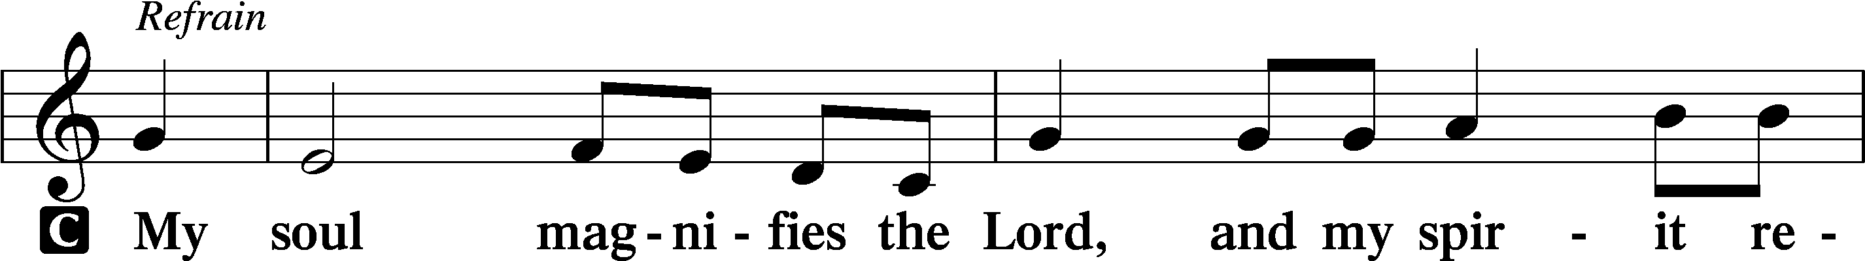
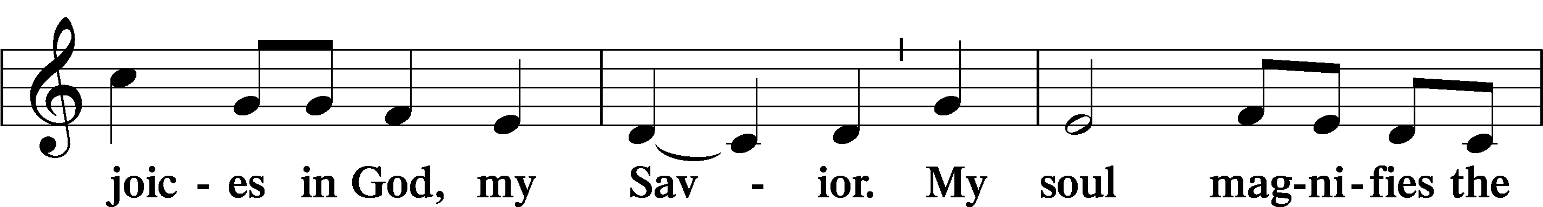
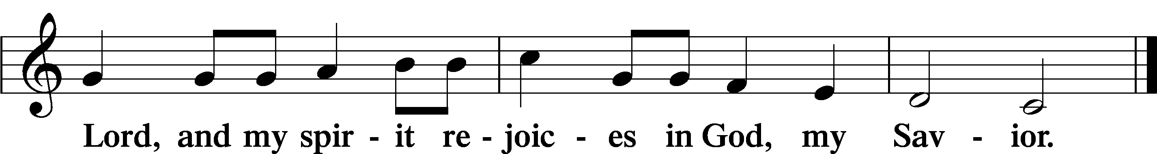
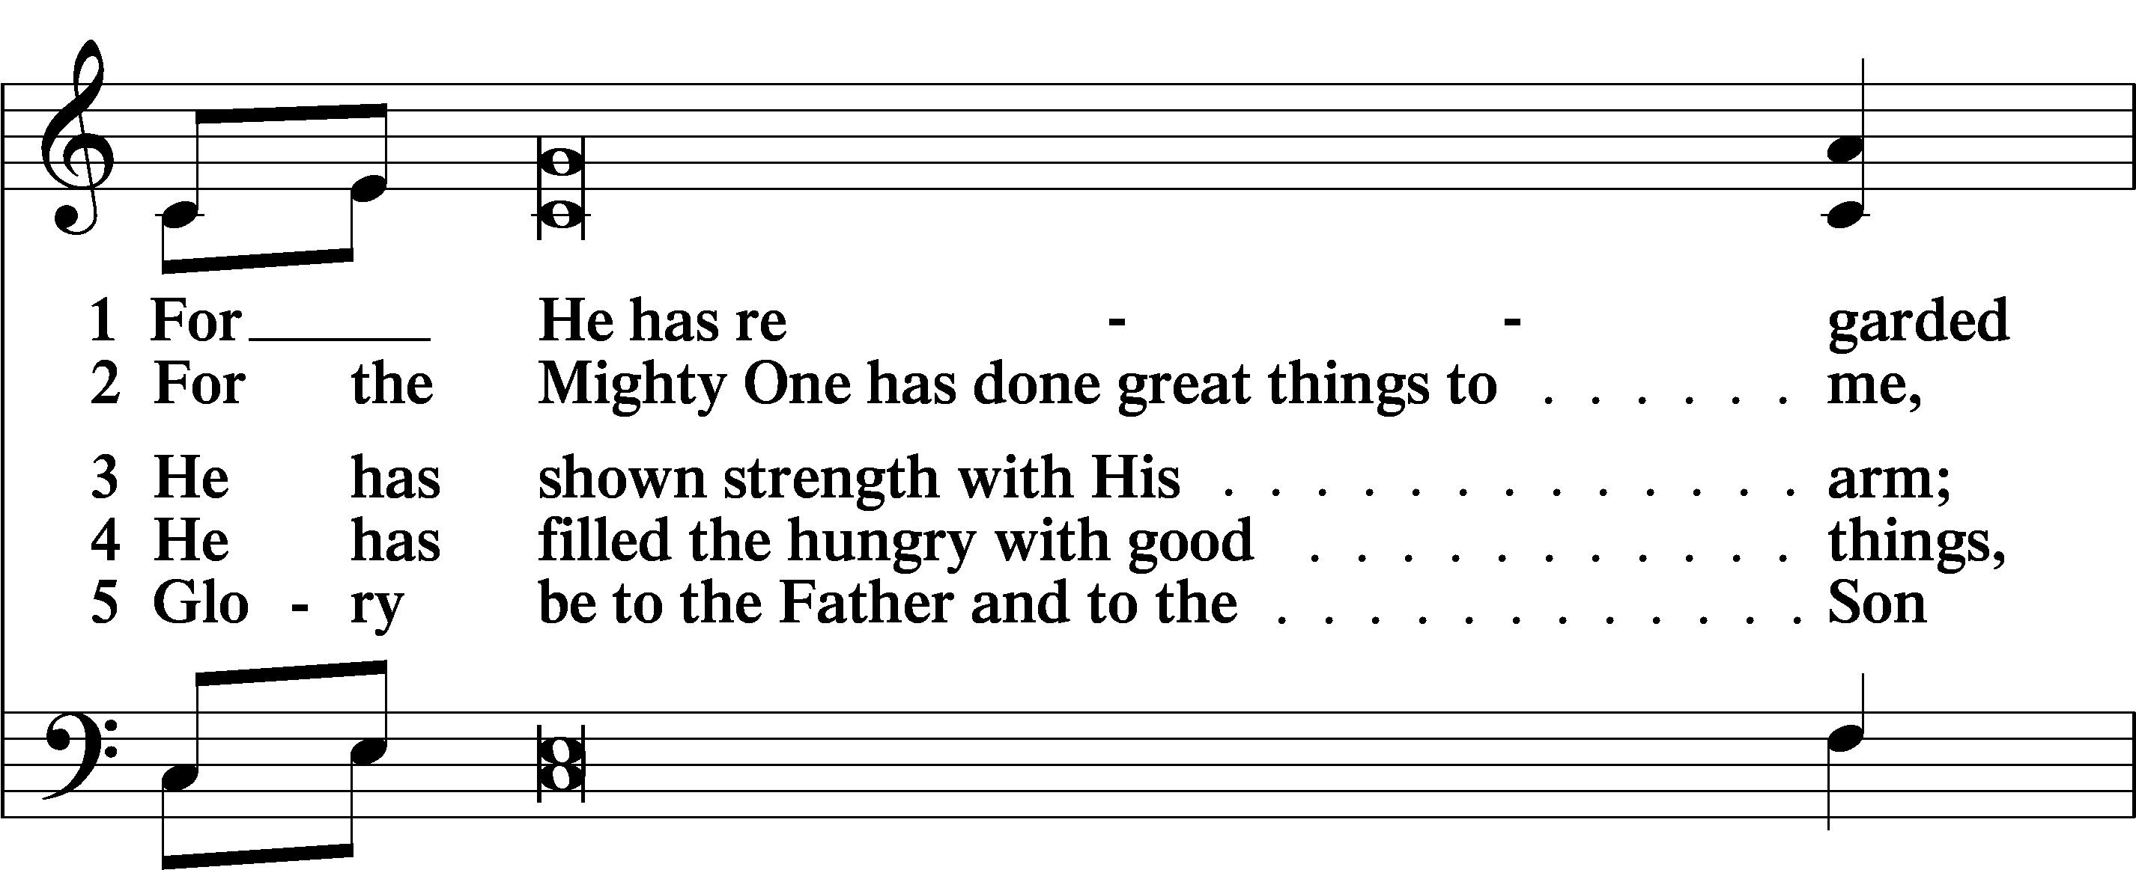
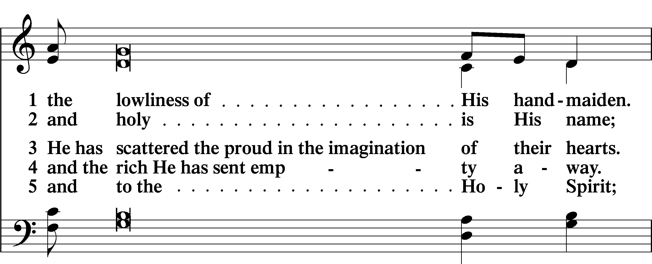
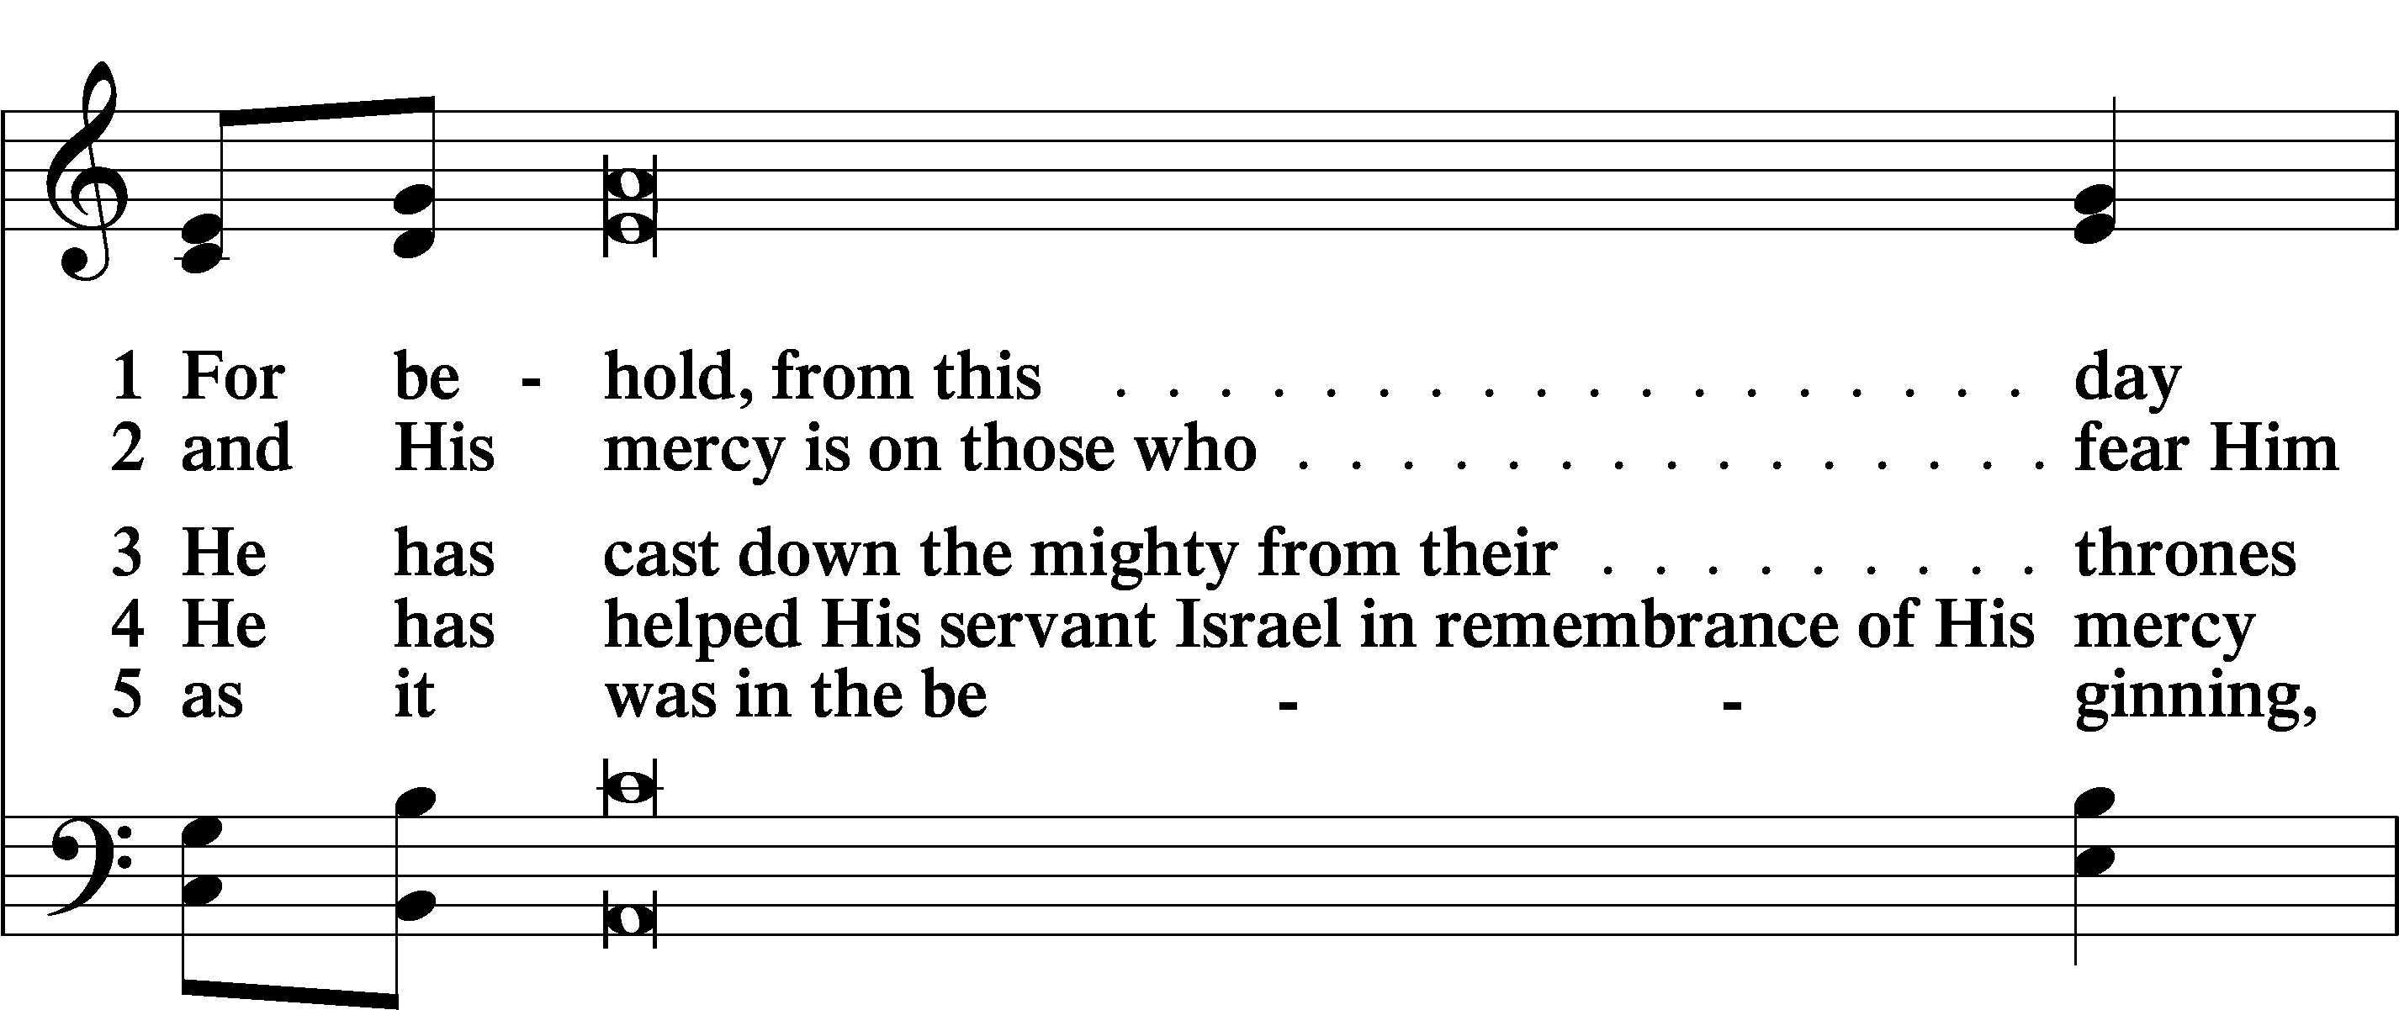
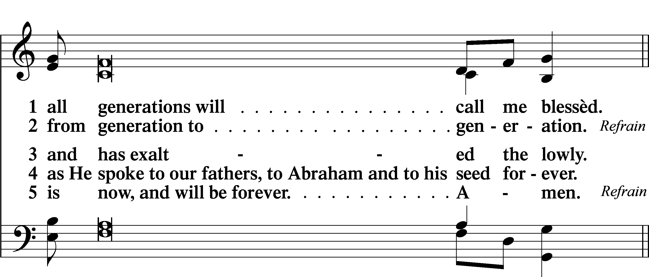

Sit

Offering

Prayer

Kneel/Stand

Litany (Lent) LSB 249
The congregation’s response may begin just as the leader’s petition ends so that the word “Lord” is sung simultaneously by both leader and congregation.

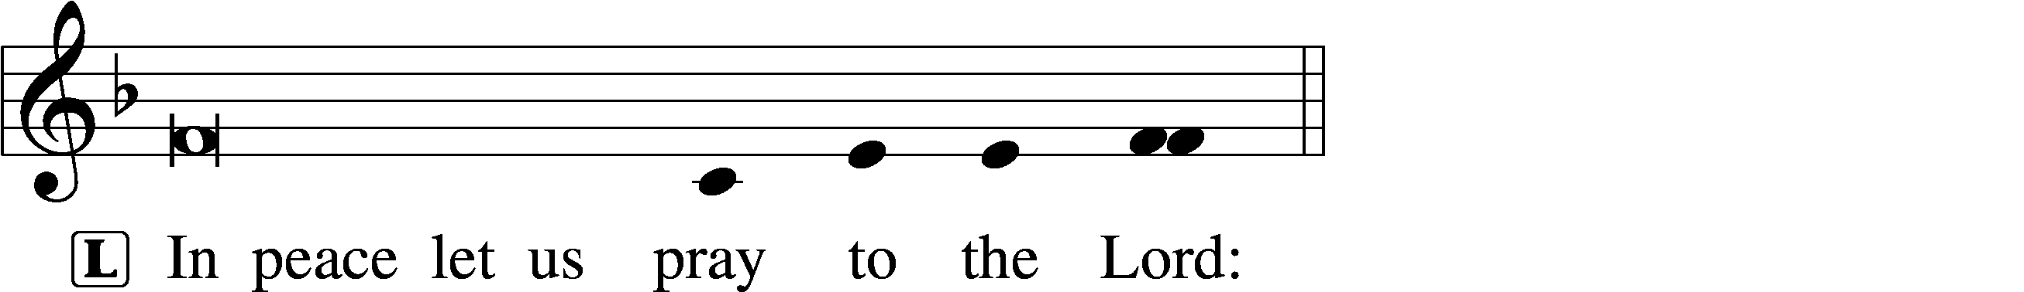
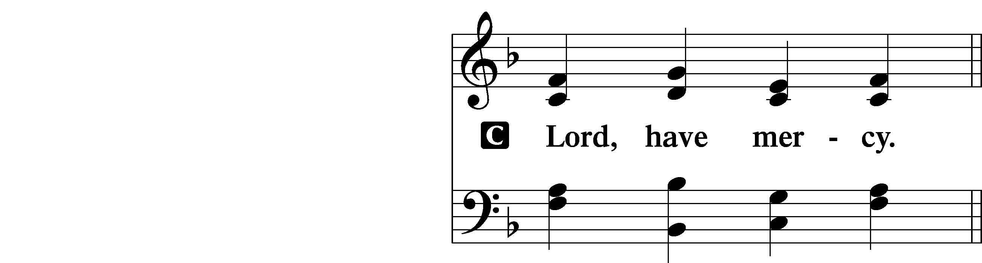

L For the peace from above and for our salvation, let us pray to the Lord:
C Lord, have mercy.
L For the peace of the whole world, for the well-being of the Church of God, and for the unity of all, let us pray to the Lord:
C Lord, have mercy.
L For this holy house and for all who offer here their worship and praise, let us pray to the Lord:
C Lord, have mercy.
L For [names of synodical and district presidents], for all pastors in Christ, for all servants of the Church, and for all the people, let us pray to the Lord:
C Lord, have mercy.
L For [name of president or monarch], for all public servants, for the government and those who protect us, that they may be upheld and strengthened in every good deed, let us pray to the Lord:
C Lord, have mercy.
L For those who work to bring peace, justice, health, and protection in this and every place, let us pray to the Lord:
C Lord, have mercy.
L For those who bring offerings, those who do good works in this congregation, those who toil, those who sing, and all the people here present who await from the Lord great and abundant mercy, let us pray to the Lord:
C Lord, have mercy.
L For favorable weather, for an abundance of the fruits of the earth, and for peaceful times, let us pray to the Lord:
C Lord, have mercy.
L For our deliverance from all affliction, wrath, danger, and need, let us pray to the Lord:
C Lord, have mercy.
L For . . . [additional bids for prayer may be inserted here] . . . let us pray to the Lord:
C Lord, have mercy.

The prayers then continue:

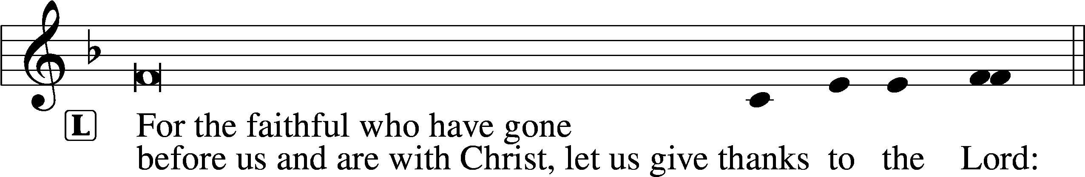
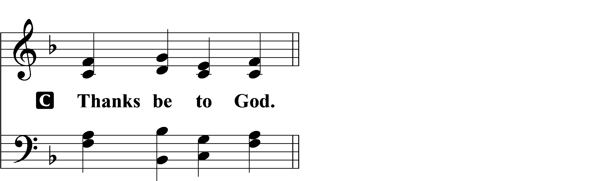
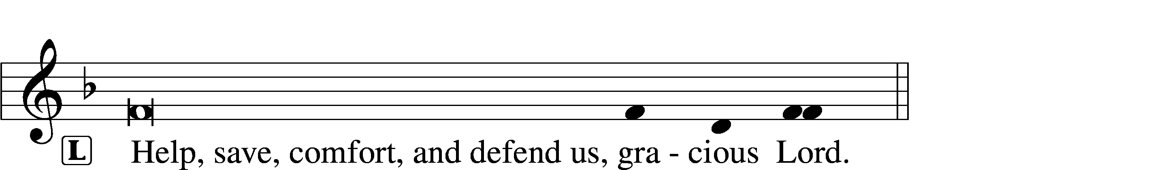

Silence for individual prayer may follow.

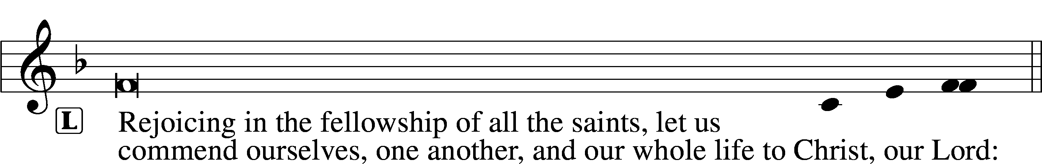
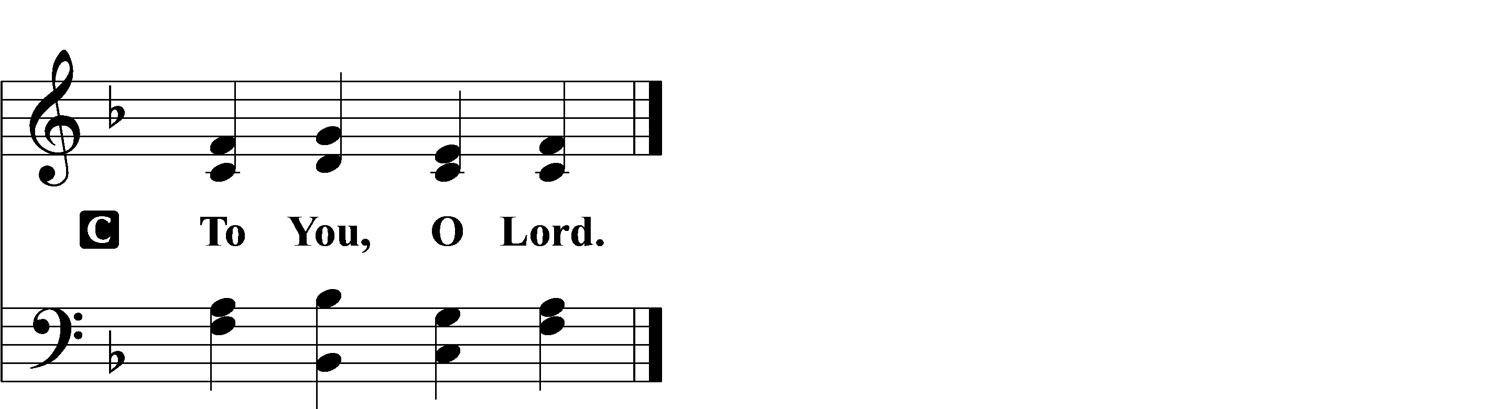

Collect For Peace
L O God, from whom come all holy desires, all good counsels, and all just works, give to us, Your servants, that peace which the world cannot give, that our hearts may be set to obey Your commandments and also that we, being defended from the fear of our enemies, may live in peace and quietness; through Jesus Christ, Your Son, our Lord, who lives and reigns with You and the Holy Spirit, one God, now and forever.

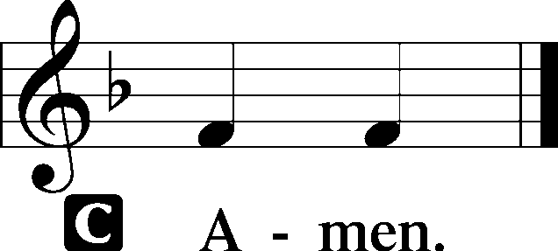

Lord’s Prayer LSB 251
L Taught by our Lord and trusting His promises, we are bold to pray:
C Our Father who art in heaven,
hallowed be Thy name,
Thy kingdom come,
Thy will be done on earth
as it is in heaven;
give us this day our daily bread;
and forgive us our trespasses
as we forgive those
who trespass against us;
and lead us not into temptation,
but deliver us from evil.
For Thine is the kingdom
and the power and the glory
forever and ever. Amen.

Stand

Benedicamus LSB 252
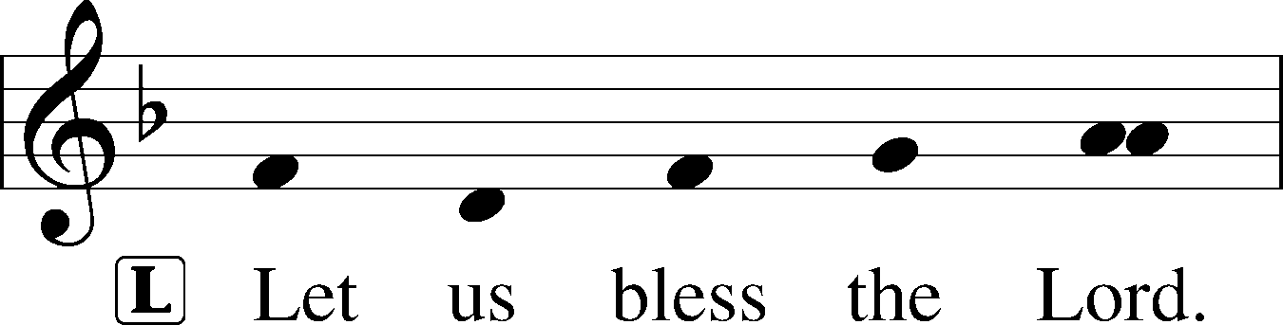
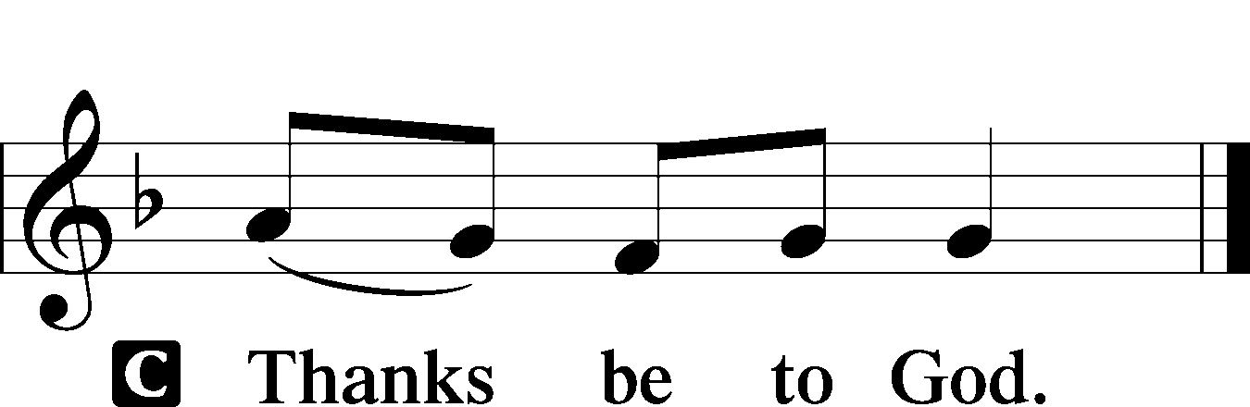

Benediction LSB 252
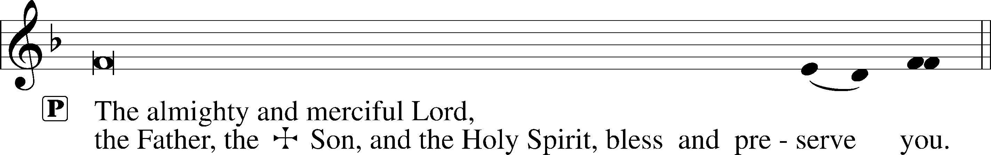

Hymn to Depart

Acknowledgments
Evening Prayer from Lutheran Service Book
Unless otherwise indicated, Scripture quotations are from the ESV® Bible (The Holy Bible, English Standard Version®), copyright © 2001 by Crossway, a publishing ministry of Good News Publishers. Used by permission. All rights reserved.
Created by Lutheran Service Builder © 2018 Concordia Publishing House.

