Fourth Sunday in Advent
RORATE COELI
Shower, O Heavens

Greetings and Announcements
Lighting of the Advent Wreath

Brief Order of Confession Insert
LITURGY OF THE WORD
Entrance Hymn Hark, the Glad Sound 35
Apostolic Greeting
Kyrie p.78
Collect
Old Testament Lesson Deuteronomy 18:15 – 19
Psalm 111 p.270
Epistle Lesson Philippians 4:4 – 7

Holy Gospel St. John 1:19-28
Sermon Rev Christopher Porter
Hymn of the Day O Come, O Come, Emmanuel 34
The Nicene Creed p.84
LITURGY OF THE SACRAMENT
All Baptized and repentant sinners who accept our doctrine and confess that we receive the true body and blood of Christ in the Holy Communion under the forms of bread and wine are welcome to commune at this altar. If you are not yet Baptized, or do not share our confession, you may come to the altar for a blessing. Approach with arms crossed over chest to indicate that you desire to receive a blessing

The Prayers p.85
Sharing the Peace
Offering
Offertory p.87
The Great Thanksgiving p.88
The Communion
Lamb of God
Communion Hymns 225, 226, 200 p.92 p.72
Post-Communion Canticle p.92
Post-Communion Prayer p.74
Benediction
Sending Hymn People, Look East 626
Dismissal
Postlude

Pastor Christopher Porter
Mobile: 248 794 2263
Home: 540 313 4912

Christian Education: 9:30am
Divine Service of Holy Communion: 11:00am

A baby changing station is available in the nursery in the Education wing.

Special Needs Box
Please use the box on the front pew and on the table at the back entrance for donations to the Special Needs Fund.

Contact Information
Church Office: 540-465-5456
www.LebanonLutheranChurch.org
pastor.lebanon@gmail.com
Like us on Facebook: Lebanon Lutheran Church
Prayer Requests: Matthew Brumback, Georgia, Lucy King, Virginia Orndorf, Mary Alice Pingley, Bessie and Annie Clem, Nadine Buckle, Melvin Harris, Debbie Porter, and all caregivers.

Virginia Orndorff has moved to Consulate Senior Care, room 314A.

General Announcements
Spring Arbor Bible Study on Romans: Monday,10am at Spring Arbor Senior Care in Winchester.
Luther’s Large Catechism Study: Monday, 7pm at the church.
Winchester House Bible Study on the Gospel of Luke: Tuesday at 10am at the Winchester House.

Christmas Eve Candlelight Eucharist: Tuesday, 7pm.
Christmas Day Eucharist: Wednesday, 10am. Bring you best singing voice!

Noisy Offering: December 29.
First Sunday Fellowship: January 5 at Box Office Brewery after the Divine Service.

LOOKING TO THE FUTURE
Congregational Meeting: February 9, 2020.

Bulletin Announcements: Contact Missy Hockman missyhockman@yahoo.com or Brenda Rose rosesplumbinginc@gmail.com

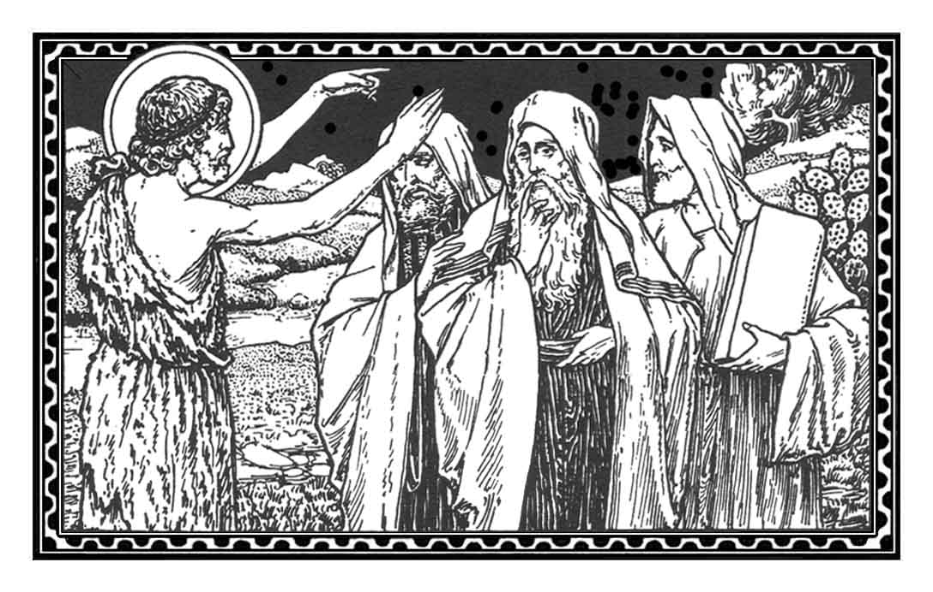
Lebanon Lutheran Church
Lebanon Church, Virginia

The Fourth Sunday of Advent
RORATE COELI
Shower, O Heavens
December 22, 2019

