Seventeenth Sunday after Trinity
October 13, 2019

Prelude
Brief Order of Confession p.77
LITURGY OF THE WORD
Entrance Hymn Seek Ye First 783
Greeting p.78
Canticle of Praise Glory to God p.79
Collect p. 82
Old Testament Lesson: Proverbs 25:6 – 14
Psalm 91 p. 258
Epistle Lesson Ephesians 4:1 – 6

Gospel Acclamation Alleluia p.83

Holy Gospel St. Luke 14:1 – 11
Sermon Rev. Christopher Porter
Hymn of the Day O Christ Our Hope 300
The Apostles’ Creed p.85
LITURGY OF THE SACRAMENT
The Prayers p.86
Sharing the Peace
Anthem
Offertory Let the Vineyards be Fruitful p.87
Offertory Prayer p.87
The Great Thanksgiving p.88
The Communion
Continuous Communion. Approach altar by center aisle and return to your seat by side aisle. Receive the Lord’s body from the pastor and receive the Lord’s blood from the communion assistants. Please place used glasses in the empty tray.

Lamb of God p.92
Communion Hymns 204, 203, 214 p.72
Post-Communion Canticle Thank the Lord p.92
Post-Communion Prayer p.94
Benediction
Sending Hymn May We Your Precepts 353
Announcements
Dismissal

All Baptized and repentant sinners who confess that we receive the true body and blood of Christ in the Holy Communion under the forms of bread and wine are welcome to commune at this altar. If you are not yet Baptized, or do not share our confession, you may come to the altar for a blessing. Approach with arms crossed over chest to indicate that you desire to receive a blessing.

Pastor Christopher Porter
Mobile: 248 794 2263
Home: 540 313 4912

Christian Education: 9:30am
Divine Service with Holy Communion: 11:00am

A baby changing station is available in the nursery in the Education wing.

Chancel flowers are given in memory of Sonny and Helen Hodson by Steve and Shirley Foster.
Special Needs Box
Please use the box on the front pew and on the table at the back entrance for suggestions or donations to the Special Needs Fund.

Contact Information
Church Office: 540-465-5456
www.LebanonLutheranChurch.org
pastor.lebanon@gmail.com
Like us on Facebook: Lebanon Lutheran Church
Prayer Requests: Ernest Pingley, Nadine Buckle, Michael, and all caregivers.

General Announcements

Spring Arbor Bible Study on Romans: Monday,10am at Spring Arbor Senior Care in Winchester.

Luther’s Large Catechism Study: Monday, 7pm at the church.

Apple Butter! October 11 and 12.

October 25 – 27: Dean McGettigan will be visiting and worshiping us to get to know our congregation.

October 27: Lebanon will host a special gathering at Box Office Brewery to celebrate our Lutheran Heritage and the Reformation!

Bulletin Announcements: Contact Missy Hockman missyhockman@yahoo.com or Brenda Rose rosesplumbinginc@gmail.com

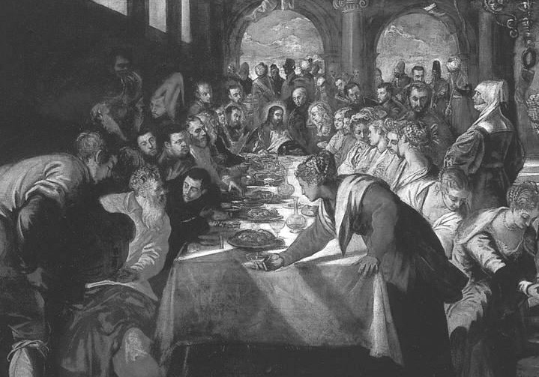
“But when you are invited, go and sit in the lowest place, so that when your host comes he may say to you, ‘Friend, move up higher.’”

Luke 7:10

Lebanon Lutheran Church
Lebanon Church, Virginia

Seventeenth Sunday after Trinity
October, 13 2019

