Sixteenth Sunday after Trinity

Prelude
Brief Order of Confession p.77
LITURGY OF THE WORD
Entrance Hymn All Hail the Power of Jesus’ Name 328
Greeting p.78
Canticle of Praise Glory to God p.79
Prayer of the Day p. 82
Old Testament Lesson: 1 Kings 17:17 – 24
Psalm 30 p. 228
Epistle Lesson Ephesians 3:13 – 21

Gospel Acclamation Alleluia p.83

Holy Gospel St. Luke 7:11 – 17
Sermon Rev. Christopher Porter
Noisy Offering
Hymn of the Day Jesus, Thy Boundless Love to Me 336
The Apostles’ Creed p.85
LITURGY OF THE SACRAMENT
The Prayers p.86
Sharing the Peace p.86
Anthem
Offertory Let the Vineyards be Fruitful p.87
Offertory Prayer p.87
The Great Thanksgiving p.88
The Words of Institution p.89
The Lord’s Prayer p.91
The Communion
Continuous Communion. Approach altar by center aisle and return to your seat by side aisle. Receive the Lord’s body from the pastor and receive the Lord’s blood from the communion assistants. Please place used glasses in the empty tray.
Lamb of God p.92
Communion Hymns 204, 203, 214 p.72
Post-Communion Canticle Thank the Lord p.92
Post-Communion Prayer p.94
Benediction
Sending Hymn O God, Our Help in Ages Past 320
Announcements
Dismissal

All Baptized and repentant sinners who confess that we receive the true body and blood of Christ in the Holy Communion under the forms of bread and wine are welcome to commune at this altar. If you are not yet Baptized, or do not share our confession, you may come to the altar for a blessing. Approach with arms crossed over chest to indicate that you desire to receive a blessing.

Pastor Christopher Porter
Mobile: 248 794 2263
Home: 540 313 4912

Christian Education: 9:30am
Divine Service with Holy Communion: 11:00am

A baby changing station is available in the nursery in the Education wing.

Chancel flowers are given in memory of Sonny and Helen Hodson by Steve and Shirley Foster.

Special Needs Box
Please use the box on the front pew and on the table at the back entrance for suggestions or donations to the Special Needs Fund.

Contact Information
Church Office: 540-465-5456
www.LebanonLutheranChurch.org
pastor.lebanon@gmail.com
Like us on Facebook: Lebanon Lutheran Church
Prayer Requests: Ernest Pingley, Nadine Buckle, and all caregivers.

General Announcements

Spring Arbor Bible Study on Romans: Monday,10am at Spring Arbor Senior Care in Winchester.

Luther’s Large Catechism Study: Monday, 7pm at the church.

Apple Butter! October 11 and 12.

Reformation Feast: October 27, 1:30pm at Box Office Brewery.

Bulletin Announcements: Contact Missy Hockman missyhockman@yahoo.com or Brenda Rose rosesplumbinginc@gmail.com

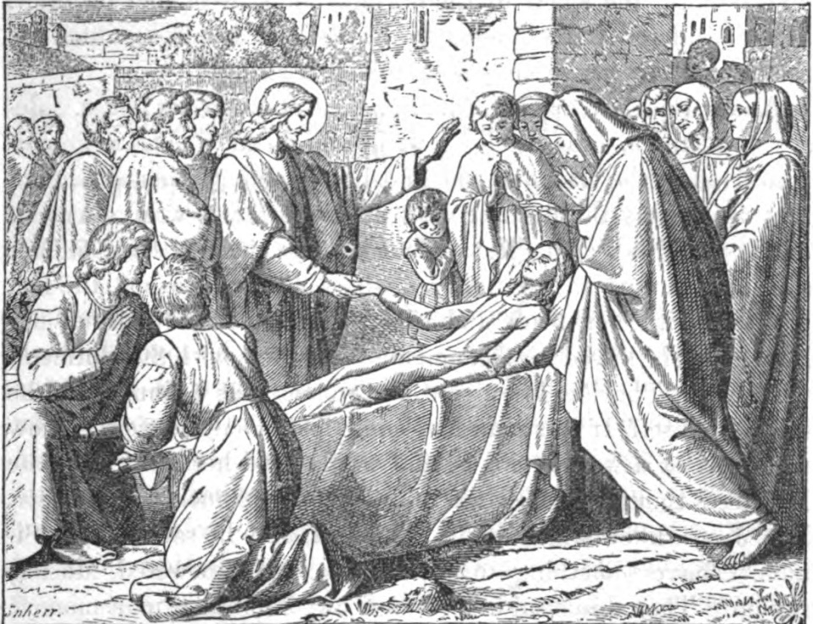
And when the Lord saw her, he had compassion
on her and said to her, “Do not weep.”

Luke 7:13

Lebanon Lutheran Church
Lebanon Church, Virginia

Sixteenth Sunday after Trinity
October 6, 2019

