Fourteenth Sunday After Trinity
September 22, 2019

Prelude
Brief Order of Confession p.77
LITURGY OF THE WORD
Entrance Hymn
Greeting p.78
Canticle of Praise Glory to God p.79
Prayer of the Day p. 82
Old Testament Lesson: Proverbs 4:10 – 23
Psalm 91 p. 258
Epistle Lesson Galatians 5:16 – 24

Gospel Acclamation Alleluia p.83

Holy Gospel St. Luke 17:11 – 19
Sermon Rev. Christopher Porter
Hymn of the Day Lord Whose Love in Humble Service 423
The Apostles’ Creed p.85
LITURGY OF THE SACRAMENT
The Prayers p.86
Sharing the Peace p.86
Anthem
Offertory Let the Vineyards be Fruitful p.87
Offertory Prayer p.87
The Great Thanksgiving p.88
The Words of Institution p.89
The Lord’s Prayer p.91
The Communion
Continuous Communion. Approach altar by center aisle and return to your seat by side aisle. Receive the Lord’s body from the pastor and receive the Lord’s blood from the communion assistants. Please place used glasses in the empty tray.
Lamb of God p.92
Communion Hymns 204, 203, 214 p.72
Post-Communion Canticle Thank the Lord p.92
Post-Communion Prayer p.94
Benediction
Sending Hymn
Announcements
Dismissal

All Baptized and repentant sinners who confess that we receive the true body and blood of Christ in the Holy Communion under the forms of bread and wine are welcome to commune at this altar. If you are not yet Baptized, or do not share our confession, you may come to the altar for a blessing. Approach with arms crossed over chest to indicate that you desire to receive a blessing.

Pastor Christopher Porter
Mobile: 248 794 2263
Home: 540 313 4912

Christian Education: 9:30am
Divine Service with Holy Communion: 11:00am

A baby changing station is available in the nursery in the Education wing.

Chancel flowers are given in memory of Sonny and Helen Hodson by Steve and Shirley Foster.
Special Needs Box
Please use the box on the front pew and on the table at the back entrance for suggestions or donations to the Special Needs Fund.

Contact Information
Church Office: 540-465-5456
www.LebanonLutheranChurch.org
pastor.lebanon@gmail.com
Like us on Facebook: Lebanon Lutheran Church
Prayer Requests: Ernest Pingley, Nadine Buckle, and the family of Julia Gochenour, and all caregivers.

General Announcements

Spring Arbor Bible Study on Romans: Monday,10am at Spring Arbor Senior Care in Winchester.

Luther’s Large Catechism Study: Monday, 7pm at the church.

Winchester House Bible Study: Tuesday, 10am at the Winchester House Senior Center.

Luther’s Large Catechism Study: Monday, 7pm at the Church.

Apple Butter! October 11 and 12.

Bulletin Announcements: Contact Missy Hockman missyhockman@yahoo.com or Brenda Rose rosesplumbinginc@gmail.com

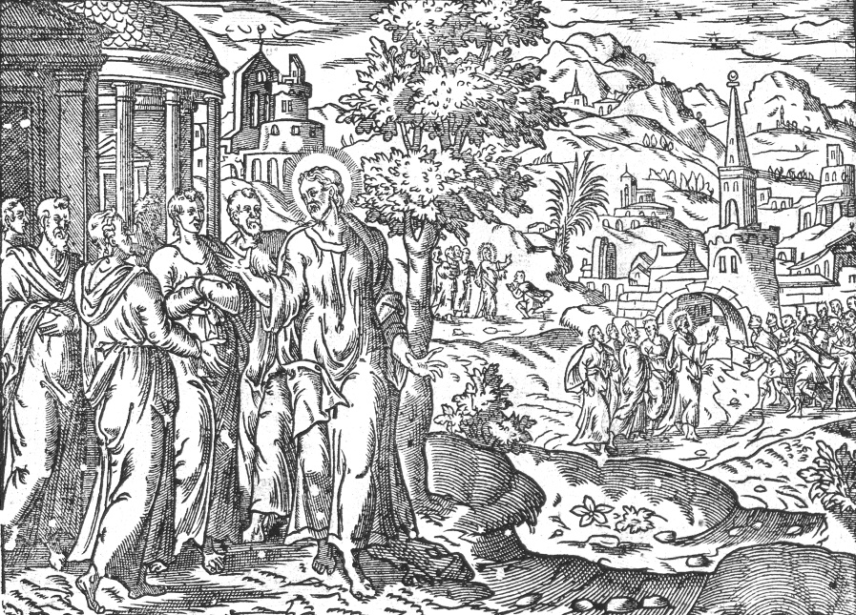
And as he entered a village, he was met by ten lepers, who stood at a distance and lifted up their voices, saying, “Jesus, Master, have mercy on us.”

Luke 17:12-13

Lebanon Lutheran Church
Lebanon Church, Virginia

Fourteenth Sunday After Trinity
September 22, 2019

