Thirteenth Sunday After Trinity
September 15, 2019

Prelude
Brief Order of Confession p.77
LITURGY OF THE WORD
Entrance Hymn In the Cross of Christ I Glory 104
Greeting p.78
Canticle of Praise Glory to God p.79
Prayer of the Day p. 82
Old Testament Lesson: 2 Chronicles 28:8-15
Psalm 32 p. 287
Epistle Lesson Galatians 3:15-22

Gospel Acclamation Alleluia p.83

Holy Gospel St. Luke 10:23-37
Sermon Rev. Christopher Porter
Hymn of the Day Beneath the Cross of Jesus 107
The Apostles’ Creed p.85
LITURGY OF THE SACRAMENT
The Prayers p.86
Sharing the Peace p.86
Anthem
Offertory Let the Vineyards be Fruitful p.87
Offertory Prayer p.87
The Great Thanksgiving p.88
The Words of Institution p.89
The Lord’s Prayer p.91
The Communion
Continuous Communion. Approach altar by center aisle and return to your seat by side aisle. Receive the Lord’s body from the pastor and receive the Lord’s blood from the communion assistants. Please place used glasses in the empty tray.
Lamb of God p.92
Communion Hymns 204, 203, 214 p.72
Post-Communion Canticle Thank the Lord p.92
Post-Communion Prayer p.94
Benediction
Sending Hymn Let Us Ever Walk With Jesus 487
Announcements
Dismissal

Pastor Christopher Porter
Mobile (248) 794-2263
Home (540) 313-4912

All Baptized and repentant sinners who confess that we receive the true body and blood of Christ in the Holy Communion under the forms of bread and wine are welcome to commune at this altar. If you are not yet Baptized, or do not share our confession, you may come to the altar for a blessing. Approach with arms crossed over chest to indicate that you desire to receive a blessing.

9:30am – Christian Education
11:00am - Divine Service with Holy Communion

A baby changing station is available in the nursery in the Education wing.

Special Needs Box
Please use the box on the front pew and on the table at the back entrance for suggestions or donations to the Special Needs Fund.

Contact Information
Church Office: 540-465-5456
www.LebanonLutheranChurch.org
pastor.lebanon@gmail.com
Like us on Facebook: Lebanon Lutheran Church
Prayer Requests:
Ernest Pingley, Anna Clem, Nadine Buckle, and the family of Julia Gochenour, and all caregivers.
General Announcements
Spring Arbor Bible Study on Romans: Monday,10am at Spring Arbor Senior Care in Winchester.

Luther’s Large Catechism Study: Monday, 7pm at the church.

Winchester House Bible Study: Tuesday, 10am at the Winchester House Senior Center.

Luther’s Large Catechism Study: Monday, 7pm at the Church.

Apple Butter! October 11th and 12th.

Bulletin Announcements: Contact Missy Hockman missyhockman@yahoo.com or Brenda Rose rosesplumbinginc@gmail.com

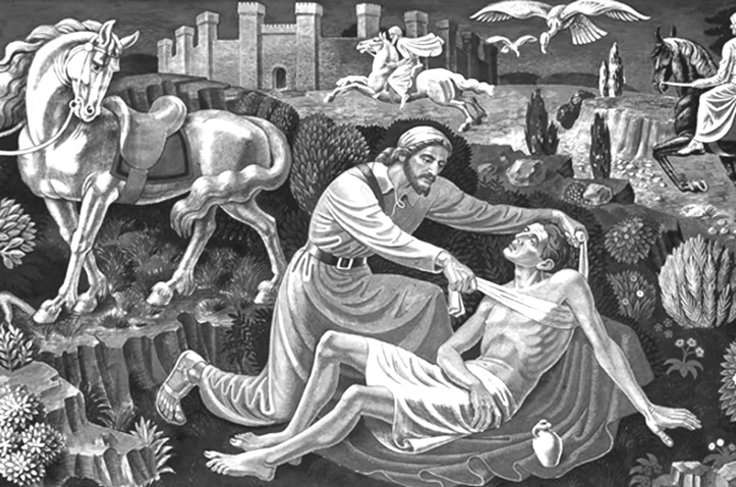
But he, desiring to justify himself, said to Jesus,
“And who is my neighbor?”

Luke 10:29

Lebanon Lutheran Church
Lebanon Church, Virginia

Thirteenth Sunday After Trinity
September 15, 2019

