Twelfth Sunday After Trinity
September 8th , 2019
Prelude
Brief Order of Confession p.77
LITURGY OF THE WORD
Entrance Hymn I Love Your Kingdom, Lord 368
Greeting p.78
Canticle of Praise Glory to God p.79
Prayer of the Day p. 82
Old Testament Lesson: Isaiah 29:17 – 24
Psalm 146 p. 287
Epistle Lesson 2 Corinthians 3:4 – 11

Gospel Acclamation Alleluia p.83

Holy Gospel St. Mark 7:31 – 37
Sermon Rev. Christopher Porter
Hymn of the Day Rise Up O Saints of God 383
The Apostles’ Creed p.85
LITURGY OF THE SACRAMENT
The Prayers p.86
Sharing the Peace p.86
Anthem
Offertory Let the Vineyards be Fruitful p.87
Offertory Prayer p.87
The Great Thanksgiving p.88
The Words of Institution p.89
The Lord’s Prayer p.91

The Communion
Continuous Communion. Approach altar by center aisle and return to your seat by side aisle. Receive the Lord’s body from the pastor and receive the Lord’s blood from the communion assistants. Please place used glasses in the empty tray.
Lamb of God p.92
Communion Hymns 204, 203, 214 p.72
Post-Communion Canticle Thank the Lord p.92
Post-Communion Prayer p.94
Benediction
Sending Hymn Lead on O King Eternal 495
Announcements
Dismissal

Pastor Christopher Porter
Mobile (248) 794-2263
Home (540) 313- 4912

All Baptized and repentant sinners who confess that we receive the true body and blood of Christ in the Holy Communion under the forms of bread and wine are welcome to commune at this altar. If you are not yet Baptized, or do not share our confession, you may come to the altar for a blessing. Approach with arms crossed over chest to indicate that you desire to receive a blessing.

9:30am – Christian Education
11:00am - Divine Service with Holy Communion

A baby changing station & nursery is available in the Education wing.

“Special Needs Box” - Please use the box on the front pew and on the table at the back entrance for suggestions or donations to the Special Needs Fund.

Contact Information
Church Office: 540-465-5456
www.LebanonLutheranChurch.org
pastor.lebanon@gmail.com
Like us on Facebook: Lebanon Lutheran Church
Prayer Requests:
Ernest Pingley, Anna Clem, Nadine Buckle, Julia Gochenour,
And all caregivers.

General Announcements
Spring Arbor Bible Study on Romans: Monday,10am at Spring Arbor Senior Care in Winchester.

Winchester House Bible Study: Tuesday 10am at the Winchester House Senior Center

Luther’s Large Catechism Study: Monday, 7pm at the Church.

Apple Butter! October 11th and 12th.

Bulletin Announcements: Contact Missy Hockman missyhockman@yahoo.com or Brenda Rose rosesplumbinginc@gmail.com

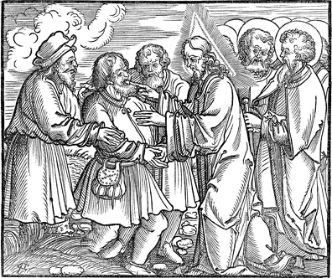
And they brought to him a man who was deaf
and had a speech impediment, and they begged him to lay his hand on him.

Mark 7:32

Lebanon Lutheran Church
Lebanon Church, Virginia

Twelfth Sunday After Trinity
September 8th, 2019

